Drawing Discrimination

Exploring redlining and discriminatory federal New Deal housing policy’s lasting imprint on homeownership, home equity, and wealth building opportunities across New York City

**Ryan Best**

M.S. Data Visualization Candidate, Parsons School of Design

B.A. Economics and International Studies, Northwestern University

--

**Thesis Advisors**

Aaron Hill

Daniel Sauter

Christian Swinehart

Richard The

Submitted in partial fulfillment of the requirements for the Masters of Science degree in Data

Visualization at the Parsons School of Design.

Special thanks to Professor Thomas Shapiro at Brandeis University and the National Community Reinvestment Coalition team including Jason Richardson and Bruce C. Mitchell, PhD for helping guide my research

May 2019

# Table of Contents

Abstract 3

Background and Introduction

What is Wealth? 4

Why Focus on Wealth? 5

What is the Racial Wealth Gap? 6

Why Focus on Housing, and How Does It Build Wealth? 7

How Does Homeownership Help Explain the Racial Wealth Gap? 8

How Did New Deal Housing Policy Facilitate Homeownership? 9

How Did New Deal Housing Policy Institutionalize Racial Discrimination? 11

Data and Methodology

Main Data Sources 15

Data Processing Methodology: Joining Census Data with HOLC Security Zones 17

Data Processing Methodology: Limitations and Considerations 19

Results and Findings

Data Analysis Approach 20

Data Analysis Results: Case Studies 21

Data Analysis Results: Limitations and Considerations 23

Visualization and Design 25

**References and Resources** 27

Appendix

Appendix A: IPUMS NHGIS Tabular Census Data Detail i

Appendix B: Median Home Value Inflation Adjustment Detail xiii

Appendix C: Data Analysis Results Case Studies Detail xiv

Appendix D: Visualization Project Snapshots xvi

# Abstract

This data visualization thesis project explores the lasting impact of redlining and discriminatory federal New Deal housing policy on homeownership, home equity, and wealth building opportunities across New York City. I connect 1938 government redlining maps of the five New York City boroughs and lower Westchester county with longitudinal census data from 1940 to 2010, tracking changes in racial composition and real estate markets within the neighborhoods included within these maps. I identify specific case study comparisons between neighborhoods with similar population demographics or homeownership markets in 1940, connect these communities to the redlining gradings they received at that time, and follow their changing and diverging housing markets through 2010. Preliminary qualitative analysis of these case studies suggests that property values and homeownership rates were depressed in many neighborhoods across New York City that received poor redlining grades or did not retain a majority white population in the decades after these official government security maps were drawn. Considerations and suggestions for further research are discussed within the *Results and Findings* section.

# Background and Introduction

“Be not deceived, wealth is strength, wealth is power, wealth is influence, wealth is justice, is liberty, is real human rights”  
– Marcus Garvey (Baradaran 2017, 82)

## What is Wealth?

Wealth is a fundamental underpinning of our American cultural identity and the American Dream. Our societal concept of an individual’s worth, capability, and success is inseparably intertwined with their ability to amass wealth. The American Dream, central to the cultural, societal, and economic foundations of the perceived American meritocracy, holds dear the ideal that anyone who is willing to work hard will have the opportunity for a more stable and prosperous life, not only for themselves but for future generations of their family. Realizing this dream, and the upward social mobility it brings, is contingent on accumulating wealth – and as much of it as possible.

As such a foundational piece of American ideals and way of life, it is essential to clearly define wealth and how it reflects the opportunities one has to participate and thrive in the American political economy. An individual’s wealth or net worth is the aggregate value of their assets and savings minus any accrued debts. Assets, which add to one’s level of wealth, are pieces of property or equity that have positive market value. Two prime examples of assets that not only add to an individual’s net worth but operate as representations of “success” in the prototypical suburban vision of the American Dream are a house (with a white picket fence) and a car. These pieces of property hold a discrete monetary value – the price their owner would be able to sell them for on the open market. Members of the American middle or lower classes often need help financing the more expensive pieces of property they own, especially their homes and automobiles. Many Americans take out mortgages to finance home purchases, incrementally building their ownership stake in that property and boosting personal equity with every monthly payment. This dynamic can significantly contribute to overall wealth levels, especially for houses that have appreciated substantially over time. Outside of tangible property, a vast amount of American wealth is held in investment funds like 401(k)’s, stock portfolios, and other financial investments. These investment holdings also contain real monetary value for their holder, who can withdraw from these accounts (whether now or at a later time) or sell the stocks they own on the trading floor. The aggregate value from all of an individual’s property and investments, plus any amount of money they’ve been able to save, raise an individual’s level of wealth. Outstanding debt detract from one’s wealth, representing money that person owes to another individual or institution. The most common types of debt include student loans, car loans, and mortgages. When these debts exceed the value of assets and savings, an individual can dip into a negative net worth. Put simply, an individual’s wealth is the amount of money they would have after they sold all their possessions, cashed in all their investments, and paid back the value of all their outstanding loans.

## Why Focus on Wealth?

Many studies of socioeconomic wellbeing tend to concentrate on income as a primary indicator of economic prosperity. Studies of poverty consider the percentage of a neighborhood’s residents whose income falls below a certain threshold. Programs that aim to provide services for underserved communities often focus on low-to-moderate income areas. On face this approach seems reasonable – using income to represent economic standing is a logical first step in exploring who is well-off in current societal structures. After all, an individual’s take-home pay dictates the amount of goods and services they’re able to purchase. However, it is wealth that gives us the financial runway and stability that greatly facilitates earning a degree, opening a business, or purchasing property – examples of larger long-term investments that can appreciate in value, create opportunities for higher income, be passed on to future generations, and in turn beget more wealth. Income can be a substantial influence on wealth if you’re able to set aside portions of your income and contribute to savings or to financial investments, but it is in this conversion to wealth that income becomes a key inflection point in our economic future. Income is one key component of economic standing, but focusing primarily on income proves to be a crucially short-handed portrayal of an individual’s economic opportunities towards prosperity, stability, and mobility. Income alone unveils only a piece of a broader picture without allowing us to fully understand a family’s economic capabilities, at times causing us to even misunderstand their extents or limits. It is more prudent to instead focus on wealth, which provides a much more holistic view of economic wellbeing.

Wealth compounds, begetting more wealth. Investments that can sit unfettered will appreciate, inflating the wealth of the investor, allowing them to purchase additional investments, thus building more and more equity, and ultimately repeating this cycle. Debt cycles can operate in a similar fashion but with opposite effects – if you need to take a loan out to purchase property or fund education, you may be charged a higher interest rate if you have any outstanding debt from previous loans. Needing more time to pay off your debt racks up increasing interest payments, drawing value out of any liabilities or savings you may have amassed, and may make it harder to find reasonable or affordable loans in the future. Having existing debt makes it easier to accumulate more debt, while having existing wealth makes it easier to accumulate more wealth, and both these cycles can be self-perpetuating. Wealth is also generational – unlike income, it can be passed from generation to generation through financial support, familial loans, and inheritance. When parents pay their children’s college tuition, act as guarantors or co-signers on a much-needed loan to finance investment, leave a nest egg in inheritance, or pass along their property and homes to their family, they give their children an undeniable advantage in accumulating wealth of their own (if not providing this wealth outright). As the popular adage conveys, “it takes money to make money,” and having wealth in the family or preexisting wealth of your own helps create paths to more wealth and sustained prosperity. Due to these generational and compounding aspects of wealth, patterns emerge that can persist for decades. Thus, looking at wealth allows us to investigate and understand how the past contextualizes and influences the present – that is, both an individual or familial past and a broader societal past.

## What is the Racial Wealth Gap?

One of the most all-encompassing manifestations of these generational wealth and poverty cycles in American society is the racial wealth gap. The racial wealth gap refers to a measurement that compares wealth levels of the most “typical” white and African American families by looking at the median – if we lined up each white family and each black family in America ordered by aggregate wealth, the median family would fall precisely in the middle of each respective distribution. Using median wealth for this comparison gives us a general indication of the broader disparities between black and white wealth in society as a whole, and more importantly allows us to have a more precise view of this disparity for the “typical” or “regular” American family of both races. The difference is stark – white wealth in the United States is almost ten times higher than black wealth. As of 2016, the median white family wealth was approximately $171,000, which towers over the net worth of $17,409 for the median black family. This gap has not only persisted, it has grown since the 1960’s. In 1963 wealth of the median white family was $47,188 higher than the median non-white family’s wealth, and by 1983 (the first year in record that measured wealth specifically within the black community) that gap had almost doubled, as it ballooned to over $92,000 (all in 2016 dollars) (McKernan et al. 2017, under “Racial and ethnic wealth disparities persist”). Through market changes, recessions, and periods of economic prosperity in the past handful of decades, the vast amount of white wealth has persistently dwarfed black wealth. This disparity in wealth also outpaces the racial income gap – median black family income is around 60% of white income ($37,000 vs $60,000), compared with median black wealth being only 10% of median white wealth (Rothstein 2017, 184)*.* On the whole, white Americans benefit from the stability and opportunity that comes with wealth disproportionately more than black Americans, who are consistently denied access to the same avenues to prosperity that are well established for white America. If wealth is quintessential to establishing one’s economic prosperity and stability, then the racial wealth gap shows the systematic denial of these economic opportunities to swaths of the American population.

These disparate economic outlooks that permeate along racial lines in modern American society have evolved through centuries of cognizant and calculated societal, economic, and political design, along with the market forces that have responded to that design. There is a confluence of factors contributing to this gap and designs that were impactful in establishing it. We’ve already established how income can help create and sustain wealth, and there has been well merited focus in social discourse around income inequality – movements like Occupy Wall Street and the 2016 Bernie Sanders Presidential campaign in the Democratic primaries made income inequality a central focal point, thrusting a conversation around income distribution into the national spotlight. Focusing our attention on measures like a family’s ability to save; levels of student loan debt; access to crucial services like education, medical services, and healthy food; and incarceration rates (just to name a few) in conjunction with income would provide crucial insight on the interrelated factors that contribute to the disheartening racial wealth gap. However, this analysis will focus specifically on housing and its impact on wealth and the racial wealth gap – the factor I believe to be the most influential vehicle for American families to build equity, move up he economic pegging order, and firmly establish themselves in the middle and upper class.

## Why Focus on Housing, and How Does It Build Wealth?

Owning a house in the suburbs with a white picket fence became synonymous with America’s picturesque vision of the middle class during a period of unprecedented economic prosperity after WWII, and for good reason – homeownership has proved to be a great accumulator of wealth in our contemporary American economic and political landscape. Homeownership is the most common path American families take to build wealth (Engel and McCoy 2008, 81). Buying a home is often the most substantial and capital-intensive investment Americans can make in their lifetime, one that is likely to have the biggest influence on their net worth and the generational wealth of their family. Modern mortgages make buying a home a prudent opportunity for building wealth for the middle class by allowing homeowners to gradually increase their ownership stake in their house over time without needing to pay for a majority of the home’s entire monetary value up front. Instead, they can put down a down payment of 5-20% of the home’s value and pay off the rest (plus interest) over an extended period of time through a mortgage loan. Over a period as long as 30 years, they can pay in installments that may not be much higher than that of a rent payment. Furthermore, most mortgages are amortized, which means that a portion of each mortgage payment is applied toward the loan principle in addition to the interest, which in turn increases the lender’s equity stake in their house. Once the mortgage is fully paid off, the lender then owns the house outright. Borrowers don’t need to reach the end of this runway and own the full value of their house outright to build wealth from their home purchase, however. Since each mortgage payment increases the ownership stake of a house’s full market value, paying off a mortgage over time gradually builds the portion of their home that the homeowner can claim as equity, attributing a higher portion of the property’s full value to their overall wealth. This means that if a family can put down just 5% for their home and make regular mortgage payments, that family will earn a whopping 100% return on their initial investment every time that house appreciates 5% in the next year (Engel and McCoy 2008, 82). Using homeownership as a vehicle to build equity in this way is the primary avenue for wealth development in the American middle class, as the majority of American middle-class wealth is tied up in home equity and property: homeownership is estimated to encapsulate over three fifths of all assets for middle-wealth American families in the 2010’s (Wolff 2017, 11)*.*

Buying or financing a first home is thus one of the most common harbingers of upward social mobility, pushing homeowners solidly into the middle class or giving them the breathing room to stay there. Family assistance in financing a down payment for that first home purchase can lessen the size of a mortgage the purchaser needs, avoid the need for costly mortgage insurance, and soften the terms or interest rates on loans needed to finance the remaining portion of the home’s value. Since home equity represents the dominant portion of middle-class family wealth and the value of houses fluctuates like any other product, commodity, or stock, the livelihood of middle-class Americans is thus overwhelmingly dependent on the housing market. It is in this dominance of middle-class wealth that the collapse of the housing market caused such dramatic financial hardship for middle-class Americans, who suffered sudden and rapid depreciation of property and mortgage values as the housing bubble burst (which on a larger scale helped set off the late-2000’s and early-2010’s Great Recession). The prospects for stability and profitability through homeownership rather than resorting to renting are different for each individual family and while using homeownership as an investment does include a fair amount of risk, its aggregate effect on wealth levels in America’s history is undeniable. Even after considering such a dramatic economic downturn centered around the housing market, middle class wealth is still all but synonymous with home equity today – as the housing market goes, so goes middle-class wealth in America. With time to appreciate, owning home equity provides a lucrative and relatively stable path to wealth accumulation, representing an asset that is almost ubiquitous in the balance sheets of American families.

## How Does Homeownership Help Explain the Racial Wealth Gap?

Not only is housing the lifeblood of middle-class families’ net worth and subsequent financial outlook, studying the housing market provides a uniquely insightful exploration of the broad causal relationships behind the racial wealth gap. This is not at all to say that housing market dynamics encompass all of the causes behind this wealth gap, nor am I explicitly claiming that housing accounts for the majority of this gap – such a claim would likely require a much more extensive socioeconomic study. Still, just as it is an impactful contributor to overall wealth levels for the American middle class, homeownership also acts as a key protagonist in establishing and entrenching societal wealth disparities. Homeownership is likely the most important asset in the establishment and growth of wealth in non-white communities, even more so than in white communities. The Brookings Institute estimated that in 2005, homeownership’s relative share of black net worth was 12% higher than its relative share of white net worth (Engel and McCoy 2008, 82). Even with this role as a key component of black net worth, black homeownership rates have consistently lagged behind homeownership rates for white Americans by around 25%. As of 2016, 68% of white Americans own equity in the home in which they live, compared to only 42% of black families. This disparity remains effectively unchanged from homeownership levels from back in the 1970’s. In 1976, white ownership levels saw almost the exact same margin over black homeownership rates (68% white homeownership, 44% black homeownership) (McKernan et al. 2017, under “Black and Hispanic families lag behind on major wealth-building measures, like homeownership”). By some estimates this gap reached levels as high as almost 50% in the mid-2000’s (Engel and McCoy 2008, 83). In fact, the size of this gap has remained at least as large as 25% across the past century of American history. Between post-Civil War America through the 1940’s, white homeownership rates hovered at just under 50%, while black homeownership rates are estimated to have been around 25%. These estimates most likely overestimate the functional rate of black homeownership, as they attributed ownership of a farm to its sharecropper – a far from lucrative arrangement that provided the sharecropper no opportunity to build any semblance of equity (Mitchell and Richardson, 2019)*.* Even during times of relative expansion or contraction of national homeownership markets, the divide between black and homeownership rates has persisted.

The entrenchment of this homeownership divide that remains pervasive in contemporary American socioeconomics is rooted in the historic systemic denial of African American access to housing markets, especially valuable housing markets in white communities, as well as the coordinated curbing of home equity value in black neighborhoods. Longstanding practices of racial discrimination and overt racism exercised by both the government and the private sector established widespread racial segregation in residential America. This coordinated effort of promoting and institutionalizing racial quarantining contributed to dramatic differences in access to homeownership during post-Great Depression and New Deal-era United States. This timeframe was one of great economic expansion and prosperity, with wages and incomes experiencing a dramatic and rapid boon. From the end of WWII until around 1973, real wages and incomes of working- and middle-class American families increased almost twofold, with African American wage and income growth matching or even outpacing the increase of white income (Rothstein 2017, 180). This increased liquidity after a period of intense economic hardship coincided with a governmental push to ease the path to homeownership for the lower- and middle-classes, allowing these higher wages to be used for wealth-building home purchases. The New Deal government policies that introduced sweeping changes and millions of dollars in subsidies within the mortgage market made buying a home more accessible than ever, thereby facilitating an unprecedented rise in homeownership and unearthing a key engine of prosperity to a broader population where it had previously been altogether out of reach.

However, these policies also served to codify racial segregation within these new mortgage credit markets, ensuring this reinvigorated wealth-building engine was exclusionary and made available only to white Americans. These policy decisions would make race all but a fundamental prerequisite to the legitimate mortgage market or to accessing any meaningful home equity for the decades to come, shutting African Americans out of a market that would yield exorbitant wealth accumulation for white Americans. This institutionalization of widely divergent access to wealth accumulation reverberates within the generational racial wealth gap that plagues American society today.

## How Did New Deal Housing Policy Facilitate Homeownership?

Before the 1930’s, mortgages looked dramatically different than they do today. The terms of typical mortgages pre-1930’s made it extremely hard and overwhelmingly costly to buy a home for members of the working- or middle-class who didn’t already have substantial levels of wealth and made lending to families of modest means a risky endeavor for financers. Mortgage lenders required a sizable down payment during this time, commonly between 40 and 70 percent, as first mortgages were limited to cover only one-half or two-thirds of the home’s appraised value. The timeframe of typical mortgages extended only between three to seven years with borrowers expected to make a “balloon payment” at the end of this runway, repaying the entire outstanding sum of the loan’s principal. Mortgages were also generally not amortized, meaning regular minimum payments made during the course of the mortgage were applied only to the loan’s interest and not to the principal. Borrowers were thus neither able to substantially reduce the total amount of their balloon payment nor earn any equity in their homes while making regular monthly payments – it was only until this balloon payment was paid in full at the end of their loan period (if they were able to afford the lump sum payment at that time) that they would gain any ownership stake in their homes. Borrowers who reached the end of their loan period without sufficient liquidity for this payment risked foreclosure. To avoid eviction, most borrowers would then finance their outstanding debt with second mortgages that carried similar terms. Functional interest rates for a typical middle-class family totaled at around 15% – in the 1920’s, mortgage rates for first mortgages averaged between 6-8%, with second mortgages that commonly followed requiring additional payments including discounts to the lender, a higher interest rate on the loan, and a potential commission to a broker. These conditions kept pre-New Deal homeownership rates relatively low (under 50%) and concentrated most home equity to already wealthy families (Jackson 2012, 204-205).

President Franklin D. Roosevelt was facing a foreclosure crisis on the horizon during the Great Depression, as the economic downturn affected the means for millions of borrowers to feasibly pay upcoming mortgage balloon payments. To address this impending crisis, he created the Home Owners’ Loan Corporation (HOLC) as a provision of the Home Owners Loan Act, which passed in June 1933 during the tail end of the “First Hundred Days” of New Deal legislation. This government-sponsored agency was empowered with protecting small urban homeowners from foreclosure and relieving the pressure they felt from looming mortgage payments they incurred during a pre-Depression period of higher valuations and earnings. To this end, the HOLC underwent a “rescue” phase during which they offered to refinance mortgages of nonfarm houses by replacing lenders’ outstanding mortgage loans with government bonds while fully insuring interest and principal on these bonds. Although this offered lenders a lower profit margin, it guaranteed a return on their initial investment, which proved to be a very attractive offer for financers dealing with borrower delinquency and potential mass foreclosure. For borrowers, these refinanced mortgages would consist of fifteen-year, fully amortized low-interest loans – a much more favorable and generous term sheet than their previous mortgages. These changes were embraced wholeheartedly by the market. In the HOLC’s “rescue” phase between July 1933 and June 1935, almost 40 percent of eligible homeowners applied for refinancing of which the HOLC accepted roughly half, supplying a total of over a million mortgages worth over $3 billion. By 1936, more than 20% of all nonfarm mortgages nationwide were held by the HOLC (Michney and Winling 2019) (Jackson 2012, 196). The HOLC provided these rescue refinancing deals to white and non-white homeowners alike at rates consistent with homeownership levels – African Americans had dramatically lower homeownership rates than their white counterparts at the time, but received HOLC assistance in proportions roughly consistent with their ownership rates in most areas nationwide (Michney and Winling 2019, 2).

With the HOLC subsidizing existing homeowners and relieving pressure of foreclosure through long-term low-interest amortized refinancing, President Roosevelt and Congress also set their sights on stimulating the market for new mortgages through creation of the Federal Housing Authority (FHA) in 1934 and the Veterans Administration (VA) in 1944. The FHA would prove to be one of the most impactful government agencies in the 21st century, as it opened the floodgates for mass investment in mortgage markets (Jackson 2012, 203) (Baradaran 2017, 106). The FHA induced mass private funding of mortgages by insuring any potential loss faced by lenders who invested money in residential home loans. It also dramatically changed the face of the mortgage market by establishing standard mortgage terms that, like the HOLC’s refinancing mortgages, were much more favorable to borrowers. These changes would truly revolutionize the home finance industry, shaping it in a way that allowed lower and middle-class families unprecedented access to affordable mortgages. First, the FHA dramatically reduced the size of down payments needed by fully insuring 80-90% of a home’s appraised value, making down payments higher than 10% unnecessary and sometimes even allowing down payments as low as 5% on some home sales. Second, they adopted and expanded the tenants of HOLC’s rescue refinancing by extending the time horizon for the loans they would insure to 25-30 years and requiring that all insured loans be amortized. This gave borrowers a more reasonable timeframe to pay back high loan balances while earning equity in their home during the process. Third, providing these substantial government guarantees dramatically reduced lender risk and consequently lowered interest rates – estimates place rates around 2-3% or 4-6%, dramatically lower than the functional rate of 15% observed prior. Finally, they established uniform minimum standards for home construction, which promoted building of homogeneous houses that were free of gross structural or mechanical deficiencies. The VA adopted much of these same standards and procedures in their effort to help sixteen million World War II veterans purchase a home. These groundbreaking changes provided new opportunities for Americans of more modest wealth to purchase homes as it became cheaper to buy than rent, and homeownership rates skyrocketed as a result. Between 1934 and 1972, overall homeownership rates ballooned from 44% to 63%. By 1950, the FHA and VA together were insuring half of all new mortgages nationwide (Baradaran 2017, 107) (Jackson 2012, 203-20) (Rothstein 2017, 63-70). While these administrations enacted changes and subsidies that revolutionized and dramatically expanded the mortgage market, they also institutionalized existing racist and discriminatory policies of segregation, creating an entrenched dichotomy between a robust white middle class and concentrated black ghettos that has become a permanent feature of American society that persists today.

## How Did New Deal Housing Policy Institutionalize Racial Discrimination?

Along with introducing long-term low-cost amortized mortgages, the HOLC and FHA also introduced standardized appraisal procedures into the mortgage landscape. These appraisal processes delineated levels of risk in issuing, holding, or insuring a mortgage in a certain area or neighborhood. For the HOLC, these appraisals became vital once they concluded offering mortgage refinancing and began managing and selling off these holdings in a “consolidation” period from 1935-1951 (Michney and Winling 2019, 2). To assess whether borrowers’ homes would likely maintain their value, the HOLC recruited local real estate agents to help make risk appraisals, which were then used to make color-coded maps of metropolitan areas across the nation. Areas were rated on a desirability and risk scale, with the safest investments coded green and the riskiest coded red. The racial composition of neighborhoods was one of the primary factors used in gauging a neighborhood’s risk: if appraisers saw a substantial African American population living in a specific area, that area was deemed unsafe for investment and colored red on the map (Rothstein 2017, 64). These maps helped coin the term ‘redlining’: race was a predominant factor in appraiser’s determination that a neighborhood was undesirable, that its property values would likely decline, and that it should be coded red on their security map. In fact, race was a better predictor of whether a neighborhood would be marked as ‘declining’ than structural characteristics typically associate with home values or desirability of urban real estate, like the age of homes, creditworthiness of its residents, access to transportation opportunities, quality of schools, or any other feature (Baradaran 2017, 105). In its assessment of one neighborhood in Brooklyn, one HOLC appraiser cited an “infiltration of Negroes” as a detrimental factor to property values, while another was characterized as a “very undesirable neighborhood of mixed races.” Predictably, both were D-rated as hazardous investments and were redlined in the HOLC’s security map of Brooklyn (Nelson et al. 2019, under “Brooklyn D8” and “Brooklyn D14”).

In a similar fashion, the FHA conducted its own appraisals to make sure it understood risks of default before a mortgage became eligible for government insurance. These appraisal standards included requirements and stipulations explicitly based on race, enforcing racial segregation on a national scale. The 1938 FHA Underwriting Manual, which “contained instructions and regulations governing the procedure and policies” of FHA underwriters dictated that “if a neighborhood is to retain stability, it is necessary that properties shall continue to be occupied by the same social and racial classes.” (Federal Housing Authority 1938, #937). According to this manual, only homogenous white communities could be trusted to retain their housing values – any “infiltration” of “inharmonious races” would directly threaten property values. The FHA strongly discouraged investment in inner cities, instead promoting loans in newly built all-white suburbs and areas where highways or other barriers separated black and white residents(Rothstein 2017, 65). These FHA policies affected which mortgages the agency would agree to insure and at what rates, in turn entrenching strong market dynamics to maintain segregated neighborhoods, subsidize homogenous white suburbs, and dampen property values in black communities. It is clear through these written policies and the mortgage insurance it issued that the FHA was only interested in insuring mortgages that facilitated white ownership – between 1934 and 1968, 98 percent of FHA loans went to white homeowners (Baradaran 2017, 108).

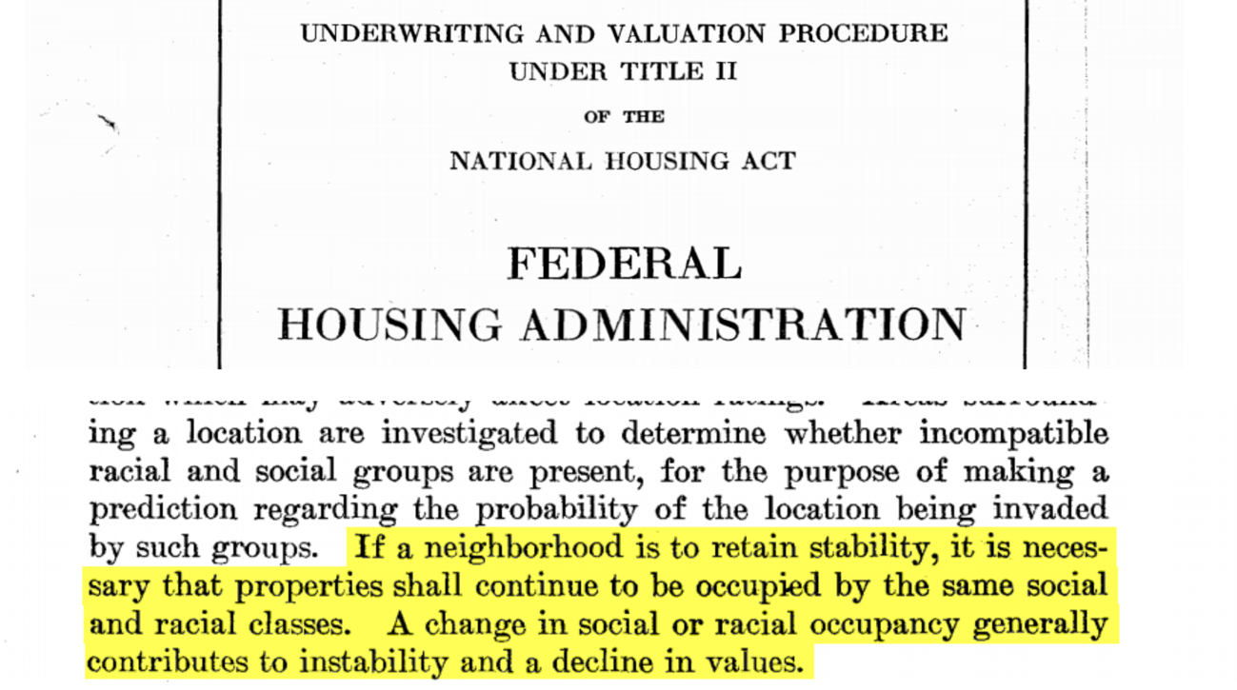

An excerpt from the 1938 FHA Underwriting Manual – the rulebook for how the federal government determined real estate value at the time. Emphasis added by me.

Neither the HOLC nor the FHA created redlining, established new patterns of segregation, or introduced assessing the desirability of neighborhoods based on race. Discriminatory policies, practices, and attitudes in housing were well established before the 1930’s. Restrictive covenants prevented the resale of property to non-white owners. Segregation was the prevailing desire of white Americans, who didn’t want to live near black neighbors. White Americans already viewed black Americans moving into their neighborhood as a signal that property values would plummet. By not channeling the lawmaking power of the federal government to challenge this racism and instead adopting these prevailing attitudes and market dynamics into official federal policy, these organizations codified and perpetuated racially-motivated perceptions of lending risk. These redlining policies (and potentially the maps themselves) were picked up by private banks to use as models for their own lending policies, security maps of perceived lending risk, and decisions on where to lend and to whom (Baradaran 2017, 106). This agreement between the Federal Government and the private banking sector to establish, protect, and subsidize all-white suburbs succeeded in excluding black residents from any meaningful participation in one of the biggest generational wealth-building engines of the last century. By making it official policy to deem black urban neighborhoods undesirable and refusing to absorb mortgage risk in black neighborhoods, the Federal Government made high-cost mortgages for lower-value properties in all-black ghettos a self-fulfilling and permanent market feature of the 20th century. Residents of redlined areas either couldn’t get a loan or could only get loans that carried substantially higher cost. Both of these dynamics served to severely depress the values of homes in their neighborhoods and curbed the potential financial benefit of any hard-fought homeownership in these areas. This value depressant was self-sustaining, since a poor appraisal rating makes loans harder to get, which in turn then affects future appraisal ratings.

Many working- and middle-class black families could have afforded to buy homes in post-WWII suburbia that cost $75,000 in today’s dollars, as many white families were able to do, had official federal policy not shut black families out of the newly expanding legitimate mortgage market. Due to this exclusion, these families were prevented from building equity in homes that have since appreciated substantially, ensuring their perpetual status as tenants suffering stagnating levels of wealth. Today, this wealth stagnation means descendants of these black families will likely be unable to fund purchases of the same homes that are now worth $350,000 or more with a current standard down payment of 20%, or around $70,000. Even after housing discrimination was legally prohibited in the Fair Housing Act of 1968 (and assuming its full enforcement and compliance in the contemporary market), it is now unaffordability that keeps many African Americans out of wealthy and still mostly white suburbs. By incentivizing all-white suburbs of homeowners and black ghettos of tenants, the government facilitated the creation of two separate mortgage markets that would perpetuate segregation and create vastly divergent opportunities for these communities to generate generational wealth.

The right that was unconstitutionally denied to African Americans in the late 1940s cannot be restored by passing a Fair Housing law that tells their descendants they can now buy homes in the suburbs, if only they can afford it. The advantage that FHA and VA loans gave to white lower-middle class in the 1940’s and 50’s has become permanent.  
(Rothstein 2017, 183)

# Data and Methodology

Studying redlining maps drawn by the HOLC in the mid to late 1930’s provides a geospatial window into where discrimination practiced by the government, private banks, and local appraisers denoted neighborhoods as undesirable and unworthy credit recipients. Even after housing discrimination based on race was officially outlawed in the 1960’s, the structures it protected still largely persist: a study by the National Community Reinvestment Coalition (NCRC) confirmed that redlined districts are today overwhelmingly occupied by poorer, lower-to-moderate income, non-white residents while greenlined areas have a predominantly white, middle-to-upper income population (Mitchell and Franco, 2019). In comparing these maps with longitudinal changes in homeownership rates, home equity, and population demographics, I aim to add to this research by exploring where the policies enacted in the New Deal may have had a lasting imprint on the real estate market and economic outlook of communities in the decades since. My research focuses on New York City and lower Westchester county, looking for evidence of the racial discrimination codified by New Deal housing policy in housing markets within the city’s neighborhoods. I explore changes in homeownership rates, home equity values, and racial compositions of each neighborhood within the HOLC security maps of Manhattan, Brooklyn, Queens, the Bronx, Staten Island, and lower Westchester county from 1940 (around the time the maps were drawn) through 2010. I then identify case studies between neighborhoods whose housing markets and population demographics shared similar characteristics in 1940 but have since diverged, highlighting how a housing market rife with discrimination may have responded to changing population and racial demographics.

## Main Data Sources

There are two main data sources I use for this visualization project. The first is HOLC security maps and primary documents from the National Archives digitized and published by *Mapping Inequality*, a research project headed by the University of Richmond’s Digital Scholarship Lab (Nelson et al. 2019). Researchers, students, and interns collaborating on this project georectified HOLC security maps, connecting scans of the original maps created in the mid to late 1930’s to the latitude-longitude geographic coordinate system. This labor-intensive process allows each security map to be used as a layer within a digital map that users can pan, zoom, and interact with on the *Mapping Inequality* interface. The project team also created GIS polygons of each graded zone within these maps and transcribed official HOLC security map ‘area descriptions’ – forms appraisers filled out for each zone grading that contain details about the neighborhood and their reasoning behind each grading decision. For each security map included in the project, the *Mapping Inequality* site provides scans of the original map, a georectified map, and georeferenced GIS data files (as both shapefiles and GeoJSON files) containing transcribed area description data when available.

From this project, I pulled down GeoJSON files representing the HOLC security maps drawn for all five New York City boroughs and lower Westchester county. Each of these files contain a list of latitude-longitude coordinates that constitute the boundaries of each graded zone polygon within that map. Also contained are additional zone properties, most notably the zone’s identifying name within the original map, its security grade received from the HOLC, and any available transcribed area descriptions. Digital transcriptions of area descriptions are provided within these data files for Manhattan, Brooklyn, and the Bronx, while Queens and Staten Island area descriptions are available on the *Mapping Inequality* website. As of May 2019, area descriptions have not yet been provided or transcribed for lower Westchester county. I focused my qualitative text analysis mainly on three sections within available area descriptions: *Favorable Influences*, *Detrimental Influences*, and *Clarifying Remarks*. These were short answer free-form text sections within the area descriptions where appraisers provided context and detail behind their decisions in their own words.

The second main source of data for this project comes from IPUMS NHGIS: the National Historical Geographic Information System (NHGIS), a data integration project by the Integrated Public Use Microdata Series (IPUMS) database within the Institute for Social Research and Data Innovation at the University of Minnesota. IPUMS NHGIS is the nation’s most comprehensive database of area-level census data and electronic boundaries describing census geography from 1790 to the present. For each decennial census from 1940 to 2010, I used the IPUMS NHGIS Data Finder tool to download census-level GIS shapefiles[1] containing individual census tract boundaries and tabular csv data files containing data tables on racial composition, housing values, and housing units by occupancy/tenure status (i.e. owner/tenant occupied) within each census tract. For each of the eight census years, I used the *ogr2ogr* command line tool to convert each GIS shapefile to a GeoJSON file limited to only include geographic census boundaries within New York state. Next, I used python (heavily leveraging the *pandas* library) to aggregate three metrics from the tabular csv files for each census tract in each census year (also only for those tracts within New York state): *percent non-white* (the proportion of that tract’s total population that were categorized as any race or ethnicity besides non-Hispanic whites), *percent homeownership* (the proportion of residencies that were owner-occupied), and *median home value* (adjusted for 2010 dollars*[2]*). Within the housing market, I focused on homeownership rates and housing values since these two metrics constitute the opportunity one has to build wealth through housing – for real estate property to increase your wealth level, you must both purchase your home *and* your home must appreciate in value over time. Finally, I joined these two files together using a unique join ID for each census tract provided by IPUMS NHGIS in both the GIS and tabular data sources, exporting a GeoJSON file for each of my eight census years. Each of these eight GeoJSON files thus contained all census tracts in New York state, and for each of those tracts included a list of latitude-longitude coordinates constituting that tract’s geographic boundaries and computed estimates for the three metrics previously mentioned within that specific census.

## Data Processing Methodology: Joining Census Data with HOLC Security Zones

Once I obtained geographic boundaries of each New York City HOLC zone (representing security grading decisions the government organization made in 1938) and subsequent census data by tract from 1940 to 2010, I needed a way to join these two geographic data sources in order to estimate results of my three computed census data statistics for each redlining zone in each census year. This data join was a rather complicated endeavor, as the boundaries of census tracts and HOLC zones don’t match cleanly – each HOLC zone can intersect with any number of census tracts to varying degrees. Furthermore, census tract boundaries can change from census to census, meaning if a specific census tract overlapped with an HOLC zone in one census, there is no guarantee it would be encompassed within that same geographic area when the next census was conducted.

I approached this problem using spatial geometric analysis, leveraging the *Shapely* python library. Using this library, I interpreted each HOLC zone and census tract as geometric polygons on a Cartesian plane. For each HOLC zone in each census year, I then conducted intersection detection analysis between that zone polygon and every census tract polygon, determining the census tracts with which the HOLC zone intersected or overlapped. For intersections between redlining zones and census tracts, I also logged the geographic area of intersection between the two polygons. I then took that geographic area of intersection as a proportion of the total geographic area of the HOLC zone polygon, computing a percent of that HOLC zone covered by each tract. Finally, I averaged the three census metrics previously computed (*percent non-white*, *percent homeownership*, and *median home value*) across all tracts that intersected with a given HOLC zone, weighting the results for each tract by the percent of the total HOLC zone’s geographic area that tract encompassed.

As an illustrative example, the HOLC zone Brooklyn D22 is located in Bergen Beach, a neighborhood in Southeastern Brooklyn on the coast of Jamaica Bay. The results from the spatial geometric data join process described above are provided for this specific HOLC zone for the 2010 census, in which the geographic boundaries of this HOLC zone intersected with three census tracts to varying degrees:

**Spatial Geometric Data Join Results: Brooklyn D22 and 2010 Census**

|  |  |  |  |  |
| --- | --- | --- | --- | --- |
| **IPUMS NHGIS Census Tract ID (GISJOIN)** | **Proportion of HOLC Zone encompassed by intersection** | **2010 Census: Percent Non-White** | **2010 Census: Percent Homeownership** | **2010 Census: Median Home Value** |
| G3600470069602 | 9.72% | 28.76% | 67.28% | $ 575,500.00 |
| G3600470070000 | 25.93% | 4.70% | 60.00% | $ 512,800.00 |
| G3600470070600 | 64.35% | 4.56% | 75.56% | $ 651,300.00 |
| Total  *(Weighted Average)* | 100.00% | 6.95% | 70.72% | $ 608,017.32 |

Table 1: Results of spatial geometric data join between Brooklyn D22 HOLC zone and 2010 census tracts. Included are any 2010 census tracts that intersected with this HOLC zone, the proportion of the HOLC zone’s total geographic area encompassed by the intersected area with each census tract, and the results of the three census metrics computed for each census tract in the 2010 census. Totals for each census metric are averaged, weighted by that census tract’s degree of geographic overlap with the Brooklyn D22 HOLC zone.

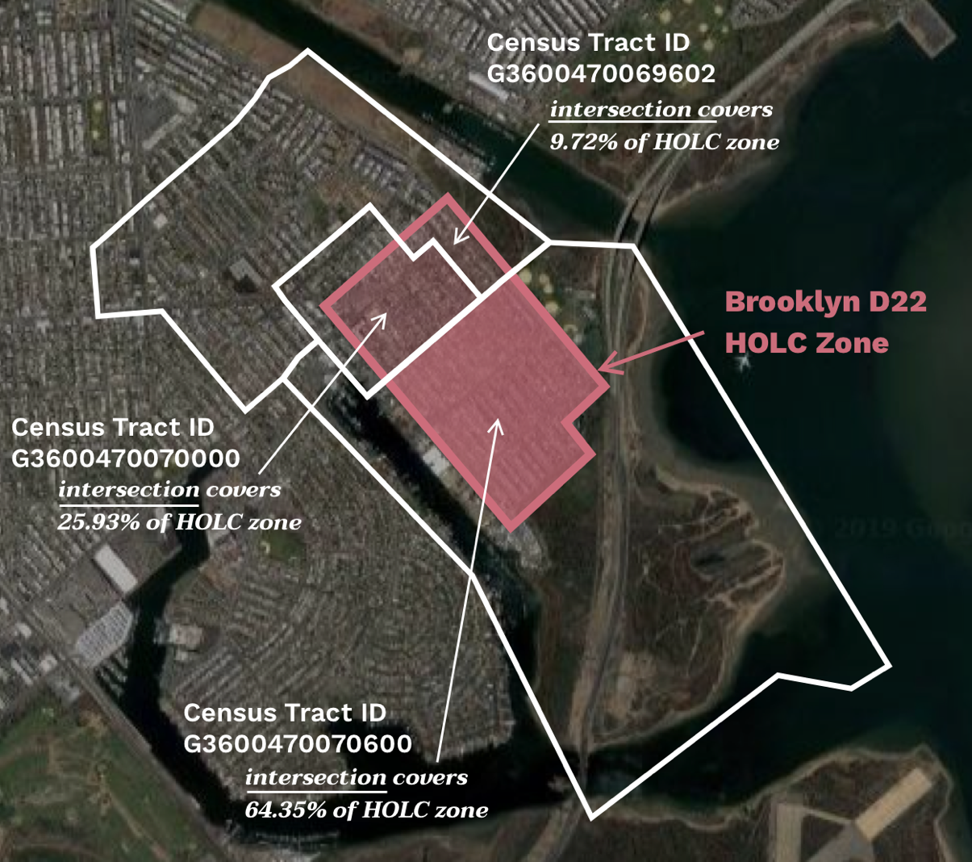  
Figure 1: Geographic view showing boundaries of the Brooklyn D22 HOLC zone (in red), boundaries of each of the three 2010 census tracts with which it intersects (in white), and the areas of intersection (shaded in red according to the proportion of the HOLC zone’s overall area that intersection encompasses). Locations of HOLC zone and census tracts are approximately placed on a current screenshot (as of May 2019) of Bergen Beach from Google Earth.

In the data I exported from this process, I also logged the total proportion of an HOLC zone’s area that was covered by census tract intersections for each census year and maintained a list with proportions of total HOLC zone coverage across each metric (since not all census tracts had defined or valid results for all three computed metrics in each census year). In the event that all intersecting census tracts did not cover the entirety of an HOLC zone, I estimated overall metric results for the HOLC zone by weighing each census tract’s results based on the area of that tract’s intersection with the HOLC zone as a proportion of the HOLC zone’s total area *that did intersect with any census tract*.

Estimates for each of my three metrics were computed using this same process for all HOLC zones for each census year included in my analysis (every decade from 1940 to 2010). I then joined these estimates back into the GeoJSON files I exported from the *Mapping Inequality* project, including them as additional data properties of each geographic HOLC zone. Thus, the final result of this lengthy and complicated data processing was a GeoJSON file that contained the following information for each HOLC zone within New York City and lower Westchester county:

* Name of borough, unique HOLC zone identifier, and security grade received
* Latitude-longitude list of coordinates constituting the boundaries of that zone
* Estimates of *percent non-white*, *percent homeownership*, and *median home value (in 2010 dollars)* metrics within that HOLC zone for each decennial census between 1940 and 2010 (where defined or valid results were returned from the spatial geometric data join described above)
* Proportion of that HOLC zone’s total area encompassed by intersections with census tracts overall and for each valid metric for each census year
* Any additional qualitative information provided for that HOLC zone by the *Mapping Inequality* project, including (but not limited to) text from that zone’s area description completed by appraisers at the time the security grades were received in 1938

## Data Processing Methodology: Limitations and Considerations

My approach to computing the three metrics from IPUMS NHGIS tabular data tables within each census tract (*percent non-white*, *percent homeownership*, and *median home value*) uses data tables and variable definitions that do not stay exactly consistent from census to census – there can be some considerable variability in census forms and designs from decade to decade. This is especially true when considering variables like race and ethnicity, the definition of and options for which have evolved over the past seven decades. This can somewhat limit the specific conclusions one can draw from directly comparing these metrics longitudinally across census years. Appendix A contains more detailed information on the specific data columns I exported from the IPUMS NGHIS database and the aggregation methodology I used to estimate values for these three metrics in each tract for all decennial censuses from 1940 to 2010.

In this vein, median home value estimates were not provided in the 1960 and 1970 census tabular data tables by IPUMS NHGIS. Like the other six decennial censuses, however, these census results did include household distributions across home value ranges which I used to estimate median home values. For example, the 1960 IPUMS NHGIS census tabular results provided the number of owner-occupied units in each of the following value ranges (before adjusting for inflation): *Under $5,000; $5,000 - $9,999; $10,000 - $14,999; $15,000 - $19,999; 20,000 - $24,999;* and *$25,000 or more*. Using the number of housing units within each of these bands, I could identify the range which each median house would fall. I then used the value halfway between the high and low bounds of that range as that tract’s estimated median home value. In the above example, if the median household would fall into the *$10,000 - $14,*999 range, I would assign that tract an estimated median home value of *$12,499.50*. If the median household within a census tract fell within the highest range, I attributed the median home value to be the lower bound of that highest range *($25,000* in the example above). If the median household within a census tract fell within the lowest range, I attributed the median home value to be halfway between zero and the upper bound of that lowest range *($2,500* in the example above). For the 1960 and 1970 censuses I used these estimated median home values for every census tract. For the other six censuses, I calculated this estimate median home value and, whenever possible, attributed it to any census tract that did not have a valid or defined median home value reported within that census’ median home value data table.

My technique to join longitudinal census estimates to HOLC zones relies primarily on a geographic and geospatial approach: I weight the results for a particular census tract more heavily if that tract has a larger geographic overlap with the HOLC zone in question. This approach does not consider population size of each census tract, however, and thus risks overemphasizing census results from a particular tract that might be larger in geographic size but is more sparsely populated. There is likely minimal skew introduced by this bias, however, particularly because census tracts are drawn with the goal that they each should contain roughly the same population sizes. Furthermore, each HOLC zone intersects with census tracts that are located in close geographic proximity or are directly next to one another – this close proximity should hopefully cut down on any significant variability in population size within different census tracts.

# Results and Findings

## Data Analysis Approach

After completing the data acquisition and processing methodology described above, I looked through the resulting longitudinal racial composition and housing market metrics in neighborhoods across each borough in New York City to identify useful comparisons that could offer stories of how discriminatory housing markets might have responded to different HOLC security grades and/or changing population and racial demographics. My analysis approach thus relies on presenting compelling case studies of neighborhoods with similar population demographics and/or homeownership markets in 1940, connecting these neighborhoods to the gradings they received at that time, and following how they ended in 2010.

I specifically looked for neighborhoods that shared similar compositions of white/non-white residents, homeownership rates, and/or housing value baselines from the 1940 census (right around the time the security maps were drawn). I also analyzed longitudinal changes in these metrics in the decades thereafter, identifying where racial demographics and homeownership markets in one neighborhood diverged from another. An additional criterion for the neighborhoods I evaluated was that they received differing redlining grades in the HOLC security maps, since I wanted to explore how housing discrimination reflected in these gradings in conjunction with these neighborhoods’ racial composition might have impacted the wealth-building housing opportunities available to its residents. Looking at case studies with this perspective and choosing neighborhoods based on these criteria allows for interesting contextual counterfactuals – by comparing neighborhoods that started with similar housing markets and underwent diverging changes in racial demographics, we can examine how a discriminatory response to an established or emerging non-white population may have manifested in how homeownership and property values progressed differently in these areas.

## Data Analysis Results: Case Studies

Following the approach outlined above, I pulled out neighborhood comparison case studies in each borough within New York City. These five case studies explore how discrimination may have influenced individual housing markets differently – whether the comparisons are focused on different metrics within the housing markets (i.e. homeownership and/or housing values) or how discrimination manifested in different ways. Each of these comparisons act as insightful archetypes and anecdotes of housing discrimination’s lasting impact on New York City, offering a first glimpse into where and how redlining may have contributed to imbalanced opportunities to build wealth through homeownership.

Many of the neighborhoods I chose for these case study analyses group together multiple HOLC zones located in close geographic proximity. I averaged estimates of my three census metrics *(percent non-white, percent homeownership,* and *median home value)* across the HOLC zones within these neighborhoods to generate overall estimates for each neighborhood in each census year. Appendix C contains detail on the HOLC zones I included within each neighborhood for these comparison case studies, along with tables detailing the estimates of the three metrics within these neighborhoods across all census years (including the estimates for all HOLC zones used to generate neighborhood-level results).

In Manhattan, I compare dramatically different housing market developments in redlined Harlem (zones D19 through D26) and greenlined Upper East Side (zones A3 through A7), close neighbors uptown. In the 1940's, over 95% of residents in both neighborhood zones lived as tenants. In the decades since, homeownership in Harlem has lagged behind substantial gains in Upper East Side. Homeownership has consistently climbed in this greenlined area of the Upper East Side over the past seventy years, which is now one of the most lucrative real estate markets in the world. In redlined Harlem, often considered the cultural center of black America and one of the only majority non-white neighborhoods in 1940's New York, homeownership has stayed low. My estimate of homeownership in these greenlined zones within the Upper East Side is now more than four times greater than in the redlined zones in Harlem.

Two residential neighborhoods in eastern Queens – Little Neck (zones B12 and B13) and Brookville (zones D23 and D26) – may portray the damaging effects of housing discrimination on property values. My estimates of housing prices in these two neighborhoods were closer together before their racial demographics changed. In 1960, both areas were overwhelmingly white, with only $60k separating the value of their average homes (in 2010 dollars). In the decades since, housing prices in now majority-minority Brookville haven't caught up with increases in Little Neck, where the median house is now worth almost $400k more.

Todt Hill has enjoyed some of the most substantial home market gains among all Staten Island neighborhoods, both in homeownership and home value. In the 1940's, greenlined Todt Hill (zone A3) and a redlined area spanning New Brighton, Tompkinsville, and Stapleton (zones D2 and D3) were both predominantly white with incredibly similar property values around $85k (in 2010 dollars). The racial demographics of these neighborhoods now look different, as majority white Todt Hill is now neighbored by more multi-racial communities to its northeast. Todt Hill is one of the more exclusive and expensive real estate markets in Staten Island today, where I estimate homeownership rates and property values are both more than double those of the redlined neighborhoods outlined above.

While I focus heavily on redlining’s impact on housing opportunities for non-white populations across New York neighborhoods, many immigrant and foreign-born communities classified as ‘white’ also faced substantial housing discrimination. Appraiser descriptions explaining their redlining grades often cite communities or nationalities that would today be classified as ‘white,’ providing evidence that large immigrant and foreign-born white populations were also subject to discrimination. These communities were also seen as a detrimental influence to property values and suffered restricted access to mortgages. For example, a zone in southwestern Brooklyn between Bay Ridge and Borough Park (D16) was given a D-rating in part due to its “Low grade Italian population of questionable occupation and income” (Nelson et al. 2019, under “Brooklyn D16”). Another zone just a handful of blocks further north (D14) was also given a D-rating, and among the detrimental influences cited as evidence for this redlining decision was an observation of “Mixed races, Italian, Danish, Polish, Swedish, Jewish” (Nelson et al. 2019, under “Brooklyn D14”).

Located in southern Brooklyn’s Coney Island peninsula on the shores of the Atlantic Ocean, Brighton Beach (zone C24) may provide further evidence of this damaging housing discrimination against immigrant communities. Brighton Beach has stayed majority white since the 1940's, but its property value increases and homeownership rates haven't outpaced many majority-minority neighborhoods. There is a large immigrant and foreign-born white population in Brighton Beach, especially Russians and Jews – populations who were also perceived as a detrimental influence to property values and were subject to housing discrimination, but are included alongside native-born whites in a white/non-white distinction. The homeownership market in Brighton Beach has remained remarkably consistent with that in majority-minority Crown Heights (zone B4), where white flight and migration from the American South and the Caribbean contributed to the neighborhood's rapidly changing population demographics in the 1960's.

Finally, comparing trends across Bronx neighborhoods Country Club (zone C13) and Fordham (zone B8) may provide evidence suggesting that even in neighborhoods receiving more favorable redlining grades, the emerging presence of non-white residents may have been met with suppressed property values and restricted access to mortgages. In their security mapping initiative, HOLC appraisers considered myriad factors in assessing potential real estate risk, with race one of the most prominent. If two areas had similar population demographics at the time the maps were drawn, they could very well have been given divergent ratings for reasons outside of race exclusively. However, if an emerging presence of non-white residents developed in a neighborhood in the decades after redlining grades were given, there was often a housing market backlash against these new non-white neighbors, regardless of that neighborhood’s redlining grade. When the HOLC drew their security map of the Bronx in 1938, Fordham was considered a more desirable real estate investment than Country Club, with appraisers especially citing more convenient access to public transportation (Nelson et al. 2019, under “Bronx B8” and “Bronx C13”). These two neighborhoods were almost exclusively white in the mid-1900's, with Country Club being a more owner-centric market and Fordham having a much higher proportion of renters. Property values in Fordham, which saw an influx of non-white residents from 1970 to 1990, are still quite a bit lower than in Country Club, where I estimate that homes are now almost $200k more valuable.

## Data Analysis Results: Limitations and Considerations

My approach to provide case studies that offer comparisons of how housing markets and racial demographics developed in choice neighborhoods receiving different redlining grades in HOLC security maps within each New York City borough aims to provide contextual archetypes and anecdotes of where and how housing discrimination may have impacted a variety of New York communities. The causal implications that can be drawn from this approach are limited, however, since there are many other factors affecting real estate markets that are not considered here. This approach does not include key considerations like square footage of housing units, age of houses in a neighborhood, access or proximity to city amenities like public transportation, quality of schools, or other economic factors that influence real estate markets and home property values. As such, the case studies and comparisons offered in this thesis are most appropriately interpreted as preliminary qualitative analyses. More detailed investigations and/or in-depth statistical studies that control for more of these economic considerations mentioned above but absent in this research would likely be needed in order to establish a more substantive causal link between these phenomena.

Additionally, this neighborhood-by-neighborhood approach does not analyze redlining and housing discrimination’s effect on New York City as a whole, instead exploring evidence of its impact on specific neighborhoods. There have been numerous studies, research projects, and writings focused on the lasting impact of redlining and housing discrimination on the racial wealth gap in broader contexts than what is covered here – with many at their most broad evaluating the policies on a national level (a few of which are cited as references and sources for this project). As such, interpretations of this project’s findings are most appropriate at the neighborhood level, as is provided in explanations of case study results above.

# Visualization and Design

This project’s data visualization establishes the historical concept and context of redlining in broad strokes, explains the grading system of redlining maps, shows the results of these gradings across New York City neighborhoods, and tells the stories of each case study neighborhood comparison in a visual context. This visualization also encourages users to explore the maps of redlining grades across New York City, providing an opportunity for them to ask their own questions and unearth potential threads of housing discrimination themselves. The webpage housing the visualization leverages a web interactivity tactic nicknamed *scrollytelling*. As the user scrolls through the webpage, the visualization changes and progresses them through the different steps of the project’s narrative and the visualization’s phases. The visualization referenced in this section is published at <https://www.ryanabest.com/ms2-2019/thesis/> as of May 21st, 2019. Screenshots of the visualizations described in this section are available in Appendix D.

The first visual and interactive component of the webpage is contained within a ‘redlining explainer’ section. This section establishes the grading system used within HOLC redlining maps through examples of first-hand quotes from appraisers alongside a representation of the map that these quotes describe. These appraiser quotes, which come from the *favorable influences, detrimental influences,* and *clarifying remarks* sections within area descriptions of HOLC zones, gives the user background of the racial context behind each grade within the maps while simultaneously showing them where these grades were assigned across New York City. This section therefore aims to provide both the context users will need to understand each grade as they advance through the project alongside initial insights explaining the lens through which government real estate appraisers viewed New York City in the late-1930’s.

Once users have progressed through each of the grading descriptions, they see the full New York City map populated with each graded neighborhood present in the HOLC maps from 1938. From this point, they are able to either progress through to individual neighborhood case studies, which aim to offer a first glimpse into where and how racial discrimination may have contributed to imbalanced opportunities to build wealth in housing, or explore the map on their own. To proceed through to individual case studies, they simply need to continue scrolling down the page (and let the *scrollytelling* interactivity guide them through each case study). There is a separate call to action for users that would instead rather proceed directly to the exploratory view, with a link provided within this view’s explanatory text and within the page’s navigation menu.

When a user proceeds to view each case study, the borough and neighborhood names being examined appear at the same time as the map on the webpage automatically pans and zooms to show the geographic boundaries of the two neighborhoods on the top left corner of the webpage. As the user continues to scroll, sparklines appear that show the results of the three main census metrics examined for the two zones being compared, along with a summary of the main story and takeaway for this particular case study. Color is used as the main variable delineating neighborhoods across all views in this neighborhood comparison section. The color of each neighborhood on the map corresponds with the gradings that neighborhood received in the HOLC map of its borough, which also matches the colors established from the earlier ‘redlining explainer’ section. Each sparkline is colored based on the grading of the neighborhood represented, and the neighborhood name within the takeaway text is given that same background color. The geographic zone outlines, sparklines, and takeaway text are all displayed on the screen at the same time, giving the user a full picture this case study in one view. Users can also hover over the sparklines to see values for the metric estimates represented in an individual year (rounded to two significant digits) for both neighborhoods.

During scrolling within a comparison, the takeaway text and map boundaries will stick to their positions on the page. This visual consistency allows the user constant access to each comparison’s key insight and geographic context throughout the entirety of that comparison. As the user then scrolls past the sparklines, they are provided a more detailed description of the context behind the neighborhoods in this comparison and their housing markets. The final portion of the comparison section displays two images of an individual house within each neighborhood, one in 1939-41 (which are from the online gallery of the New York City Municipal Archives' Tax Photograph Collection) and another in 2019 (which are from the Google Maps Street View Static API). These two images show the same building at two distinct periods in time at similar angles and perspectives, allowing users to pan between the two using an interactive click-and-drag slider. Color is once again used to delineate which building is part of which zone, implemented using a border around each set of images. Dots also appear on the map when these images are present in the view, giving the user visual context to where these houses are located within each neighborhood. Subtitles for each image communicate the building’s specific address along with its estimated market value as evaluated by the New York City Tax department.

The final view within this visualization is the exploratory view, which allows users to pan and zoom the redlining map of New York City. The explore view shows both this map and sparklines that visually resemble the sparklines from the individual neighborhood comparisons. Users can hover over a zone to see sparklines for that zone populate, and can click on a zone for its sparklines to stick on the view (until another zone is clicked). Sparklines for hovered zones will also stick until another zone is hovered over, allowing lines for two different zones to appear simultaneously. Like the comparison view, users can also hover over these sparklines to see the values for the metric estimates represented in an individual year for both zones (clicked and hovered). The zone(s) represented in the sparklines are visually highlighted on the map through opacity – zones that are clicked or hovered will have full opacity while all other zones are slightly faded. Users can then jump back to the main site (including the redlining explainer and neighborhood case study comparisons) through a call to action within the page’s navigation menu.

# References and Resources

1. Baradaran, Mehrsa. *The Color of Money: Black Banks and the Racial Wealth Gap*. Cambridge, MA: The Belknap Press of Harvard University Press, 2017.
2. Coates, Ta-Nehisi. “The Case for Reparations.” *The Atlantic,* June 2014. <https://www.theatlantic.com/magazine/archive/2014/06/the-case-for-reparations/361631/>
3. Engel, Kathleen C., and Patricia A. McCoy. “From Credit Denial to Predatory Lending: The Challenge of Sustaining Minority Homeownership.” In *Segregation: The Rising Costs for America*, edited by James J. Carr and Nandinee K. Kutty, p. 81-123. New York, NY: Routledge, 2008.
4. *Explained: The Racial Wealth Gap.* Produced by Vox and Netflix. <https://www.netflix.com/watch/80243753>.
5. Federal Housing Authority. *Underwriting Manual*. 1938. Underwriting and Valuation Procedure Under Title II of the National Housing Act <https://www.huduser.gov/portal/sites/default/files/pdf/Federal-Housing-Administration-Underwriting-Manual.pdf>.
6. Jackson, Kenneth T. *Crabgrass Frontier: The Suburbanization of the United States*. OXFORD University Press, 2012.
7. Manson, Steven, Jonathan Schroeder, David Van Riper, and Steven Ruggles. *IPUMS National Historical Geographic Information System: Version 13.0* [Database]. Minneapolis: University of Minnesota. 2018. <http://doi.org/10.18128/D050.V13.0>
8. McKernan, Signe-Mary, Caleb Quakenbush, Caroline Ratcliffe, Emma Kalish, and C. Eugene Steuerle. "Nine Charts about Wealth Inequality in America (Updated)." Nine Charts about Wealth Inequality in America (Updated). October 04, 2017. Accessed March 24, 2019. <http://apps.urban.org/features/wealth-inequality-charts/>.
9. Michney, Todd M., and Ladale Winling. "New Perspectives on New Deal Housing Policy: Explicating and Mapping HOLC Loans to African Americans." *Journal of Urban History*, January 2019. <https://doi.org/10.1177/0096144218819429>
10. Mishel, Lawrence, Josh Bivens, Elise Gould, and Heidi Shierholz. *State of Working America, 12th Edition*. Cornell University Press, 2012. <http://stateofworkingamerica.org/subjects/wealth/?reader>.  
    An Economic Policy Institute book
11. Mitchell, Bruce, PhD., and Juan Franco. "HOLC “Redlining” Maps: The Persistent Structure of Segregation and Economic Inequality." Research » NCRC. Accessed March 24, 2019. <http://maps.ncrc.org/holcreport/report/index.html>.
12. Mitchell, Bruce, PhD., and Jason Richardson, interviewed by Ryan Best at National Community Reinvestment Coalition offices in Washington D.C, Monday, March 18th 2019 at 3:30PM. <https://github.com/ryanabest/ms2-2019/blob/master/writing/interviews/ncrc_interview.md>
13. Nelson, Robert K., LaDale Winling, Richard Marciano, Nathan Connolly, et al., “Mapping Inequality,” *American Panorama*, ed. Robert K. Nelson and Edward L. Ayers, accessed March 24, 2019, [https://dsl.richmond.edu/panorama/redlining/](https://dsl.richmond.edu/panorama/redlining/#loc=16/40.8046/-74.0742&opacity=0.8&sort=190&adview=full&text=intro)
14. Rothstein, Richard. *The Color of Law: A Forgotten History of How Our Government Segregated America*. New York: Liveright Publishing Corporation, 2017.
15. Shapiro, Thomas (professor of Sociology at Brandies University), interviewed by Ryan Best over the phone, Tuesday, March 19th, 2019, 10:00AM. <https://github.com/ryanabest/ms2-2019/blob/master/writing/interviews/shapiro_interview.md>
16. U.S. Official Inflation Data, Alioth Finance, 6 May. 2019, <https://www.officialdata.org/>
17. Wolff, Edward. "Has Middle Class Wealth Recovered? For Presentation at the ASSA Meetings, LERA Session N3, “Dimensions of Wealth Inequality,”." *American Economic Association*, November 29, 2017. <https://www.aeaweb.org/conference/2018/preliminary/paper/5ZFEEf69>.

# Appendix

## Appendix A: IPUMS NHGIS Tabular Census Data Detail

Below is identifying information for the dataset and data tables exported from the IPUMS NHGIS Data Finder tool used in calculating census tract-level *percent white/non-white*, *percent homeownership*, and *median home value* metrics in each decennial census from 1940-2010. Also provided is the aggregation method for the census tract-level *percent white/non-white*, *percent homeownership*, and *median home value* metrics in each census year.

The *median home value* metric was first pulled from median value columns if provided – estimates were then taken from home distribution columns for census tracts without valid or present median value columns. For 1960 and 1970 censuses, no median value column was provided by IPUMS NHGIS, so all estimates of *median home value* are estimated using home distribution columns. For more notes on the *median home value* estimation method used with home distribution columns, please see explanations presented in the *Data Processing Methodology: Limitations and Considerations* section above.

IMPUS NHGIS Data Finder Tool: <https://data2.nhgis.org/main>

**1940**

IPUMS NHGIS Data Exported:

* Dataset: *1940 Census: Population & Housing Data [Tracts & NY Health Areas: Major Cities & Surrounds]*
  + NGHIS code: *1940_tPH_Major*
  + NHGIS ID: *ds76*
  + Geographic level: *Census Tract (by State--County)*
* Table Name: *Population*
  + Universe: *Persons*
  + Source code: *NT1*
  + NHGIS code: *BUB*
  + Data Dictionary:
    - *BUB001: Total*
* Table Name: *Population by Race*
  + Universe: *Persons*
  + Source code: *NT2*
  + NHGIS code: *BUQ*
  + Data Dictionary:
    - *BUQ001: White*
    - *BUQ002: Nonwhite*
* Table Name: *Occupied Dwelling Units by Tenure*
  + Universe: *Occupied Dwelling Units*
  + Source code: *NT27*
  + NHGIS code: *BU2*
  + Data Dictionary:
    - *BU2001: Owner occupied*
    - *BU2002: Tenant occupied*
* Table Name: *Median Value of Homes for Which Value was Reported*
  + Universe: *Homes for Which Value was Reported*
  + Source code: *NT36*
  + NHGIS code: *BVC*
  + Data Dictionary:
    - *BVC001: Median value*
* Table Name: *Homes for Which Value was Reported by Reported Value*
  + Universe: *Homes for Which Value was Reported*
  + Source code: *NT35*
  + NHGIS code: *BVB*
  + Data Dictionary:
    - *BVB001: Under $500*
    - *BVB002: $500 - $699*
    - *BVB003: $700 - $999*
    - *BVB004: $1000 - $1499*
    - *BVB005: $1500 - $1999*
    - *BVB006: $2000 - $2499*
    - *BVB007: $2500 - $2999*
    - *BVB008: $3000 - $3999*
    - *BVB009: $4000 - $4999*
    - *BVB010: $5000 - $5999*
    - *BVB011: $6000 - $7499*
    - *BVB012: $7500 - $9999*
    - *BVB013: $10000 - $14999*
    - *BVB014: $15000 - $19999*
    - *BVB015: $20000+*

Metric Aggregation Method:

* Percent white: *BUQ001*/ *BUB001*
* Percent non-white: *BUQ002 / BUB001*
* Percent homeownership: *BU2001/ ( BU2001 + BU2002 )*
* Median home value: *BVC001* (if not populated or valid for census tract, estimated using *BVB*)

**1950**

IPUMS NHGIS Data Exported:

* Dataset: *1950 Census: Population & Housing Data [Tracts: Major Cities & Surrounds]*
  + NGHIS code: *1950_tPH_Major*
  + NHGIS ID: *ds82*
  + Geographic level: *Census Tract (by State--County)*
* Table Name: *Total Population*
  + Universe: *Persons*
  + Source code: *NT1*
  + NHGIS code: *BZ8*
  + Data Dictionary:
    - *BZ8001: Total*
* Table Name: *Race*
  + Universe: *Persons*
  + Source code: *NT2*
  + NHGIS code: *B0J*
  + Data Dictionary:
    - *B0J001: White*
    - *B0J002: Negro*
    - *B0J003: Other nonwhite*
* Table Name: *Tenure and Vacancy Status*
  + Universe: *Dwelling Units*
  + Source code: *NT29*
  + NHGIS code: *B0T*
  + Data Dictionary:
    - *B0T001: Occupied: Owner occupied*
    - *B0T002: Occupied: Renter occupied*
    - *B0T003: Vacant: Vacant nonseasonal not dilapidated, for rent or sale*
    - *B0T004: Vacant: Other vacant and nonresident*
* Table Name: *Median Value*
  + Universe: *One-Dwelling-Unit Structures for Which Value Is Reported*
  + Source code: *NT42*
  + NHGIS code: *B09*
  + Data Dictionary:
    - *B09001: Median value*
* Table Name: *Value*
  + Universe: *One-Dwelling-Unit Structures for Which Value Is Reported*
  + Source code: *NT41*
  + NHGIS code: *B08*
  + Data Dictionary:
    - *B08001: Less than $3,000*
    - *B08002: $3,000 to $3,999*
    - *B08003: $4,000 to $,4,999*
    - *B08004: $5,000 to $7,499*
    - *B08005: $7,500 to $,9999*
    - *B08006: $10,000 to $14,999*
    - *B08007: $15,000 or more*

Metric Aggregation Method:

* Percent white: *B0J001*/ *BZ8001*
* Percent non-white: 1 – ( *B0J001*/ *BZ8001 )*
* Percent homeownership: *B0T001 / ( B0T001+ B0T002 + B0T003 + B0T004 )*
* Median home value: *B09001* (if not populated or valid for census tract, estimated using *B08*)

**1960**

IPUMS NHGIS Data Exported:

* Dataset: *1960 Census: Population & Housing Data [Tracts: Major Cities & Surrounds]*
  + NGHIS code: *1960_tPH*
  + NHGIS ID: *ds92*
  + Geographic level: *Census Tract (by State--County)*
* Table Name: *Total Persons*
  + Universe: *Persons*
  + Source code: *NTSUP2*
  + NHGIS code: *CA4*
  + Data Dictionary:
    - *CA4001: Total*
* Table Name: *Total Nonwhite Population*
  + Universe: *Nonwhite Persons*
  + Source code: *NT62*
  + NHGIS code: *B9T*
  + Data Dictionary:
    - *B9T001: Total*
* Table Name: *Occupied Housing Units by Tenure*
  + Universe: *Occupied Housing Units*
  + Source code: *NT58*
  + NHGIS code: *B9O*
  + Data Dictionary:
    - *B9O001: Owner-occupied*
    - *B9O002: Renter-occupied*
* Table Name: *Owner-Occupied Units Reporting Value by Value*
  + Universe: *Owner-Occupied Units Reporting Value*
  + Source code: *NT13*
  + NHGIS code: *B78*
  + Data Dictionary:
    - *B78001: Under $5,000*
    - *B78002: $5,000 - $9,999*
    - *B78003: $10,000 - $14,999*
    - *B78004: $15,000 - $19,999*
    - *B78005: $20,000 - $24,999*
    - *B78006: $25,000 or more*

Metric Aggregation Method:

* Percent white: 1 – *( B9T001*/ *CA4001 )*
* Percent non-white: *B9T001*/ *CA4001*
* Percent homeownership: *B9O001/ ( B9O001+ B9O002 )*
* Median home value: estimated using *B78*

**1970**

IPUMS NHGIS Data Exported:

* Dataset: *1970 Census: Count 4Pa - Sample-Based Population Data*
  + NGHIS code: *1970_Cnt4Pa*
  + NHGIS ID: *ds98*
  + Geographic level: *Census Tract (by State--County)*
* Table Name: *Race*
  + Universe: *Persons Before Substitution and Allocation*
  + Source code: *NT105*
  + NHGIS code: *C0X*
  + Data Dictionary:
    - *C0X001: White*
    - *C0X002: Negro*
    - *C0X003: Other*
* Dataset: 1*970 Census: Count 2 - 100% Data [Tracts, Urban Areas, Metro Areas, etc.]*
  + NGHIS code: *1970_Cnt2*
  + NHGIS ID: *ds95*
  + Geographic level: *Census Tract (by State--County)*
* Table Name: *Tenure*
  + Universe: *Occupied Units*
  + Source code: *NT31A*
  + NHGIS code: *CFA*
  + Data Dictionary:
    - *CFA001: Owned or being bought (excludes cooperative and condominium units except when there are less than five such units in the tabulation area)*
    - *CFA002: Cooperative or condominium units which are owned or being bought*
    - *CFA003: Rented for cash rent*
    - *CFA004: Rented units occupied without payment of cash rent*
* Table Name: *Value*
  + Universe: *Owner-Occupied Units*
  + Source code: *NT46A*
  + NHGIS code: *CG7*
  + Data Dictionary:
    - *CG7001: Less than $5000*
    - *CG7002: $5000-$7499*
    - *CG7003: $7500-$9999*
    - *CG7004: $10000-$12499*
    - *CG7005: $12500-$14999*
    - *CG7006: $15000-$17499*
    - *CG7007: $17500-$19999*
    - *CG7008: $20000-$24999*
    - *CG7009: $25000-$34999*
    - *CG7010: $35000-$49999*
    - *CG7011: $50000 or more*

Metric Aggregation Method:

* Percent white: *C0X001 / ( C0X001 + C0X002 + C0X003 )*
* Percent non-white: *( C0X001 + C0X002 ) / ( C0X001 + C0X002 + C0X003 )*
* Percent homeownership: *(* *CFA001 + CFA002 ) / (* *CFA001 + CFA002 + CFA003 + CFA004 )*
* Median home value: estimated using *CG7*

**1980**

IPUMS NHGIS Data Exported:

* Dataset: *1980 Census: STF 1 - 100% Data*
  + NGHIS code: *1980_STF1*
  + NHGIS ID: *ds104*
  + Geographic level: *Census Tract (by State--County)*
* Table Name: *Persons*
  + Universe: *Persons*
  + Source code: *NT1A*
  + NHGIS code: *C7L*
  + Data Dictionary:
    - *C7L001: Total*
* Table Name: *Race*
  + Universe: *Persons*
  + Source code: *NT7*
  + NHGIS code: *C9D*
  + Data Dictionary:
    - *C9D001: White*
    - *C9D002: Black*
    - *C9D003: American Indian, Eskimo, and Aleut: American Indian*
    - *C9D004: American Indian, Eskimo, and Aleut: Eskimo*
    - *C9D005: American Indian, Eskimo, and Aleut: Aleut*
    - *C9D006: Asian and Pacific Islander: Japanese*
    - *C9D007: Asian and Pacific Islander: Chinese*
    - *C9D008: Asian and Pacific Islander: Filipino*
    - *C9D009: Asian and Pacific Islander: Korean*
    - *C9D010: Asian and Pacific Islander: Asian Indian*
    - *C9D011: Asian and Pacific Islander: Vietnamese*
    - *C9D012: Asian and Pacific Islander: Hawaiian*
    - *C9D013: Asian and Pacific Islander: Guamanian*
    - *C9D014: Asian and Pacific Islander: Samoan*
    - *C9D015: Other*
* Table Name: *Tenure*
  + Universe: *Occupied Housing Units*
  + Source code: *NT26B*
  + NHGIS code: *C7W*
  + Data Dictionary:
    - *C7W001: Owner occupied*
    - *C7W002: Renter occupied*
* Table Name: *Median Value*
  + Universe: *Specified Owner-Occupied Noncondominium Housing Units*
  + Source code: *NT39*
  + NHGIS code: *C8J*
  + Data Dictionary:
    - *C8J001: Median value*
* Table Name: *Value*
  + Universe: *Specified Owner-Occupied Noncondominium Housing Units*
  + Source code: *NT38*
  + NHGIS code: *C8I*
  + Data Dictionary:
    - *C8I001: Less than $10,000*
    - *C8I002: $10,000-$14,999*
    - *C8I003: $15,000-$19,999*
    - *C8I004: $20,000-$24,999*
    - *C8I005: $25,000-$29,999*
    - *C8I006: $30,000-$34,999*
    - *C8I007: $35,000-$39,999*
    - *C8I008: $40,000-$49,999*
    - *C8I009: $50,000-$79,999*
    - *C8I010: $80,000-$99,999*
    - *C8I011: $100,000-$149,999*
    - *C8I012: $150,000-$199,999*
    - *C8I013: $200,000 or more*

Metric Aggregation Method:

* Percent white: *C9D001* / *C7L001*
* Percent non-white: 1 – ( *C9D001* / *C7L001 )*
* Percent homeownership: *C7W001/ ( C7W001+ C7W002 )*
* Median home value: *C8J001* (if not populated or valid for census tract, estimated using *C8I)*

**1990**

IPUMS NHGIS Data Exported:

* Dataset: *1990 Census: STF 1 - 100% Data*
  + NGHIS code: *1990_STF1*
  + NHGIS ID: *ds120*
  + Geographic level: *Census Tract (by State--County)*
* Table Name: *Persons*
  + Universe: *Persons*
  + Source code: *NP1*
  + NHGIS code: *ET1*
  + Data Dictionary:
    - *ET1001: Total*
* Table Name: *Race*
  + Universe: *Persons*
  + Source code: *NP6*
  + NHGIS code: *EUY*
  + Data Dictionary:
    - *EUY001: White*
    - *EUY002: Black*
    - *EUY003: American Indian, Eskimo, or Aleut*
    - *EUY004: Asian or Pacific Islander*
    - *EUY005: Other race*
* Table Name: *Tenure*
  + Universe: *Occupied Housing Units*
  + Source code: *NH3*
  + NHGIS code: *ES1*
  + Data Dictionary:
    - *ES1001: Owner occupied*
    - *ES1002: Renter occupied*
* Table Name: *Median Value*
  + Universe: *Specified owner-occupied housing units*
  + Source code: *NH23B*
  + NHGIS code: *EST*
  + Data Dictionary:
    - *EST001: Median*
* Table Name: *Value*
  + Universe: *Specified owner-occupied housing units*
  + Source code: *NH23*
  + NHGIS code: *ESR*
  + Data Dictionary:
    - *ESR001: Less than $15,000*
    - *ESR002: $15,000 to $19,999*
    - *ESR003: $20,000 to $24,999*
    - *ESR004: $25,000 to $29,999*
    - *ESR005: $30,000 to $34,999*
    - *ESR006: $35,000 to $39,999*
    - *ESR007: $40,000 to $44,999*
    - *ESR008: $45,000 to $49,999*
    - *ESR009: $50,000 to $59,999*
    - *ESR010: $60,000 to $74,999*
    - *ESR011: $75,000 to $99,999*
    - *ESR012: $100,000 to $124,999*
    - *ESR013: $125,000 to $149,999*
    - *ESR014: $150,000 to $174,999*
    - *ESR015: $175,000 to $199,999*
    - *ESR016: $200,000 to $249,999*
    - *ESR017: $250,000 to $299,999*
    - *ESR018: $300,000 to $399,999*
    - *ESR019: $400,000 to $499,999*
    - *ESR020: $500,000 or more*

Metric Aggregation Method:

* Percent white: *EUY001* / *ET1001*
* Percent non-white: 1 – ( *EUY001* / *ET1001 )*
* Percent homeownership: *ES1001/ ( ES1001 + ES1002 )*
* Median home value: *EST001* (if not populated or valid for census tract, estimated using *ESR)*

**2000**

IPUMS NHGIS Data Exported:

* Dataset: *2000 Census: SF 1a - 100% Data [Areas Larger Than Block Groups]*
  + NGHIS code: *2000_SF1a*
  + NHGIS ID: *ds146*
  + Geographic level: *Census Tract (by State--County)*
* Table Name: *Total Population*
  + Universe: *Persons*
  + Source code: *NP001A*
  + NHGIS code: *FL5*
  + Data Dictionary:
    - *FL5001: Total*
* Table Name: *Population by Race*
  + Universe: *Persons*
  + Source code: *NP007A*
  + NHGIS code: *FMR*
  + Data Dictionary:
    - *FMR001: White alone*
    - *FMR002: Black or African American alone*
    - *FMR003: American Indian and Alaska Native alone*
    - *FMR004: Asian alone*
    - *FMR005: Native Hawaiian and Other Pacific Islander alone*
    - *FMR006: Some other race alone*
    - *FMR007: Two or more races*
* Table Name: *Occupied Housing Units by Tenure*
  + Universe: *Occupied Housing Units*
  + Source code: *NH004B*
  + NHGIS code: *FKN*
  + Data Dictionary:
    - *FKN001: Owner occupied*
    - *FKN002: Renter occupied*
* Dataset: *2000 Census: SF 3a - Sample-Based Data [Areas Larger Than Block Groups]*
  + NGHIS code: *2000_SF3a*
  + NHGIS ID: *ds151*
  + Geographic level: *Census Tract (by State--County)*
* Table Name: *Median Value*
  + Universe: *Specified Owner-Occupied Housing Units*
  + Source code: *NH076A*
  + NHGIS code: *GB7*
  + Data Dictionary:
    - *GB7001: Median value*
* Table Name: *Specified Owner-Occupied Housing Units by Value*
  + Universe: *Specified Owner-Occupied Housing Units*
  + Source code: *NH074B*
  + NHGIS code: *GB5*
  + Data Dictionary:
    - *GB5001: Less than $10,000*
    - *GB5002: $10,000 to $14,999*
    - *GB5003: $15,000 to $19,999*
    - *GB5004: $20,000 to $24,999*
    - *GB5005: $25,000 to $29,999*
    - *GB5006: $30,000 to $34,999*
    - *GB5007: $35,000 to $39,999*
    - *GB5008: $40,000 to $49,999*
    - *GB5009: $50,000 to $59,999*
    - *GB5010: $60,000 to $69,999*
    - *GB5011: $70,000 to $79,999*
    - *GB5012: $80,000 to $89,999*
    - *GB5013: $90,000 to $99,999*
    - *GB5014: $100,000 to $124,999*
    - *GB5015: $125,000 to $149,999*
    - *GB5016: $150,000 to $174,999*
    - *GB5017: $175,000 to $199,999*
    - *GB5018: $200,000 to $249,999*
    - *GB5019: $250,000 to $299,999*
    - *GB5020: $300,000 to $399,999*
    - *GB5021: $400,000 to $499,999*
    - *GB5022: $500,000 to $749,999*
    - *GB5023: $750,000 to $999,999*
    - *GB5024: $1,000,000 or more*

Metric Aggregation Method:

* Percent white: *FMR001* / *FL5001*
* Percent non-white: 1 – ( *FMR001* / *FL5001 )*
* Percent homeownership: *FKN001 / ( FKN001 + FKN002 )*
* Median home value: *GB7001* (if not populated or valid for census tract, estimated using *GB5)*

**2010**

IPUMS NHGIS Data Exported:

* Dataset: *2010 Census: SF 1a - P & H Tables [Blocks & Larger Areas]*
  + NGHIS code: *2010_SF1a*
  + NHGIS ID: *ds172*
  + Geographic level: *Census Tract (by State--County)*
* Table Name: *Total Population*
  + Universe: *Total population*
  + Source code: *P1*
  + NHGIS code: *H7V*
  + Data Dictionary:
    - *H7V001: Total*
* Table Name: *Race*
  + Universe: *Total population*
  + Source code: *P3*
  + NHGIS code: *H7X*
  + Data Dictionary:
    - *H7X001: Total*
    - *H7X002: White alone*
    - *H7X003: Black or African American alone*
    - *H7X004: American Indian and Alaska Native alone*
    - *H7X005: Asian alone*
    - *H7X006: Native Hawaiian and Other Pacific Islander alone*
    - *H7X007: Some Other Race alone*
    - *H7X008: Two or More Races*
* Table Name: *Tenure*
  + Universe: *Occupied housing units*
  + Source code: *H4*
  + NHGIS code: *IFF*
  + Data Dictionary:
    - *IFF001: Total*
    - *IFF002: Owned with a mortgage or a loan*
    - *IFF003: Owned free and clear*
    - *IFF004: Renter occupied*
* Dataset: *2010 American Community Survey: 5-Year Data [2006-2010, Block Groups & Larger Areas]*
  + NGHIS code: *2006_2010_ACS5a*
  + NHGIS ID: *ds176*
  + Geographic level: *Census Tract (by State--County)*
  + Year: *2006-2010*
* Table Name: *Median Value (Dollars)*
  + Universe: *Owner-occupied housing units*
  + Source code: *B25077*
  + NHGIS code: *JTI*
  + Data Dictionary:
    - *JTIE001: Median value (dollars)*
* Table Name: *Value* 
  + Universe: *Owner-occupied housing units*
  + Source code: *B25075*
  + NHGIS code: *JTG*
  + Data Dictionary:
    - *JTGE001: Total*
    - *JTGE002: Less than $10,000*
    - *JTGE003: $10,000 to $14,999*
    - *JTGE004: $15,000 to $19,999*
    - *JTGE005: $20,000 to $24,999*
    - *JTGE006: $25,000 to $29,999*
    - *JTGE007: $30,000 to $34,999*
    - *JTGE008: $35,000 to $39,999*
    - *JTGE009: $40,000 to $49,999*
    - *JTGE010: $50,000 to $59,999*
    - *JTGE011: $60,000 to $69,999*
    - *JTGE012: $70,000 to $79,999*
    - *JTGE013: $80,000 to $89,999*
    - *JTGE014: $90,000 to $99,999*
    - *JTGE015: $100,000 to $124,999*
    - *JTGE016: $125,000 to $149,999*
    - *JTGE017: $150,000 to $174,999*
    - *JTGE018: $175,000 to $199,999*
    - *JTGE019: $200,000 to $249,999*
    - *JTGE020: $250,000 to $299,999*
    - *JTGE021: $300,000 to $399,999*
    - *JTGE022: $400,000 to $499,999*
    - *JTGE023: $500,000 to $749,999*
    - *JTGE024: $750,000 to $999,999*
    - *JTGE025: $1,000,000 or more*

Metric Aggregation Method:

* Percent white: *H7X002* / *H7V001*
* Percent non-white: 1 – ( *H7X002* / *H7V001 )*
* Percent homeownership: *( IFF002 + IFF003 ) / IFF001*
* Median home value: *JTIE001* (if not populated or valid for census tract, estimated using *JTG)*

## Appendix B: Median Home Value Inflation Adjustment Detail

Below are inflation estimates used to adjust median home values to 2010 dollars – census tract-level median home value estimations are multiplied by the value below for their specific census year. These estimates come from in2013dollars.com, a reference website maintained by the Official Data Foundation; raw data from its calculations come from the Bureau of Labor Statistics’ Consumer Price Index (CPI). Values for each year represent the dollar amount in 2010 with equivalent purchasing power as $1 in that year.

* 1930: $13.06
* 1940: $15.58
* 1950: $9.05
* 1960: $7.37
* 1970: $5.62
* 1980: $2.65
* 1990: $1.67
* 2000: $1.27
* 2010: $1

## Appendix C: Data Analysis Results Case Studies Detail

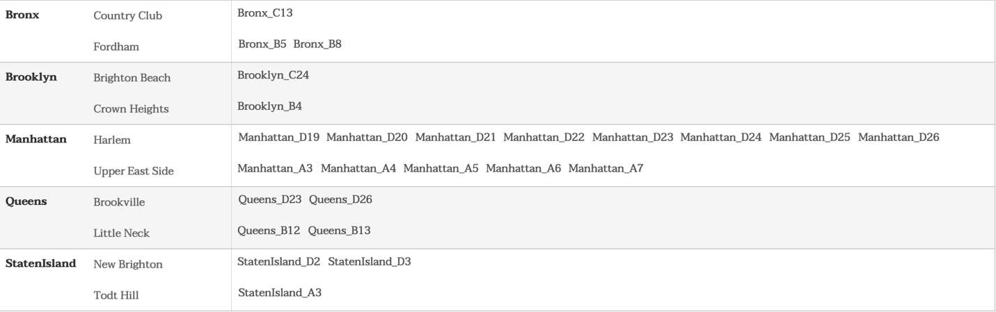

Table C1: Reference list of which HOLC zones were included within each case study comparison neighborhood

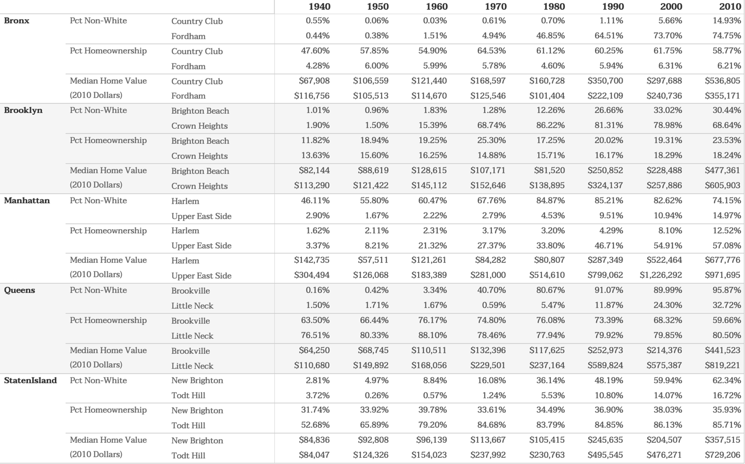

Table C2: Full results of case study comparisons for each case study neighborhood, each census metric, and each decennial census year. Results for each neighborhood in each census year are computed using averages across all HOLC zones within each neighborhood (see above).

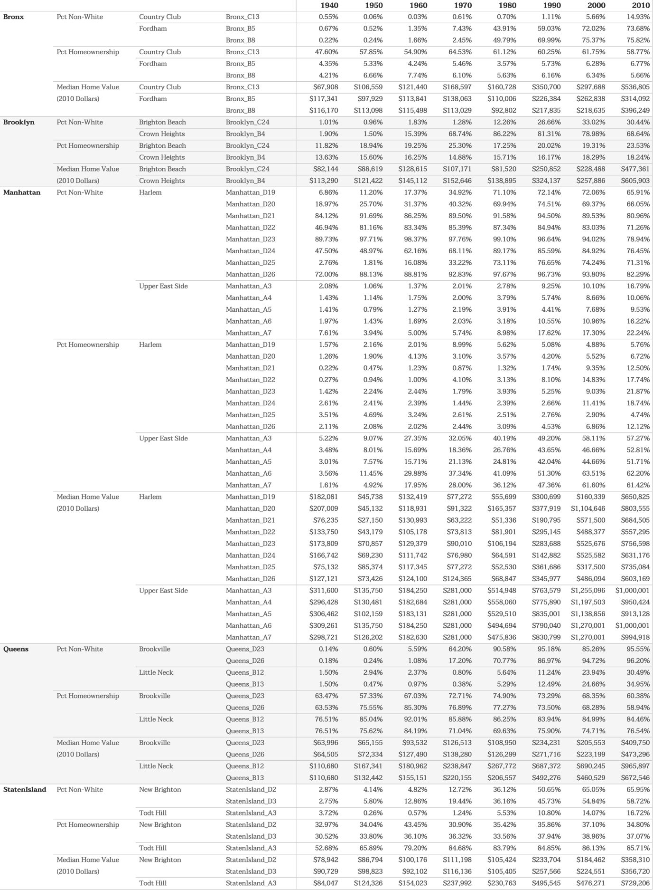

Table C3: Full results of each HOLC zone within each neighborhood

## Appendix D: Visualization Project Snapshots

Below are example screenshots of the project’s visualization webpage. As of May 21st, 2019, this project is accessible at <https://www.ryanabest.com/ms2-2019/thesis/>

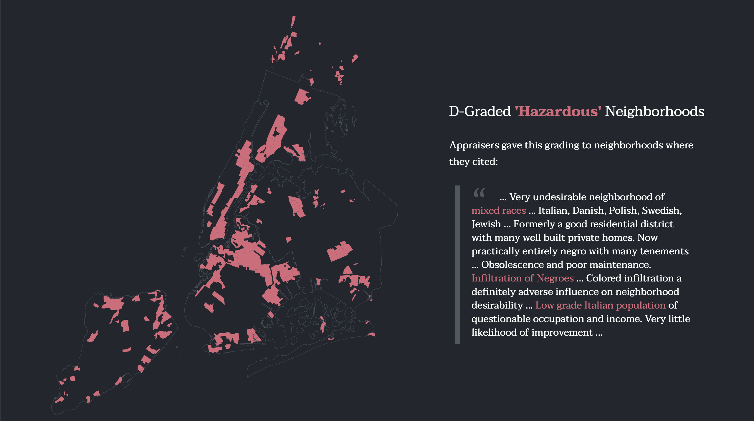

Figure D1: ‘Redlining Explainer’ section for D-Graded “Hazardous” zones

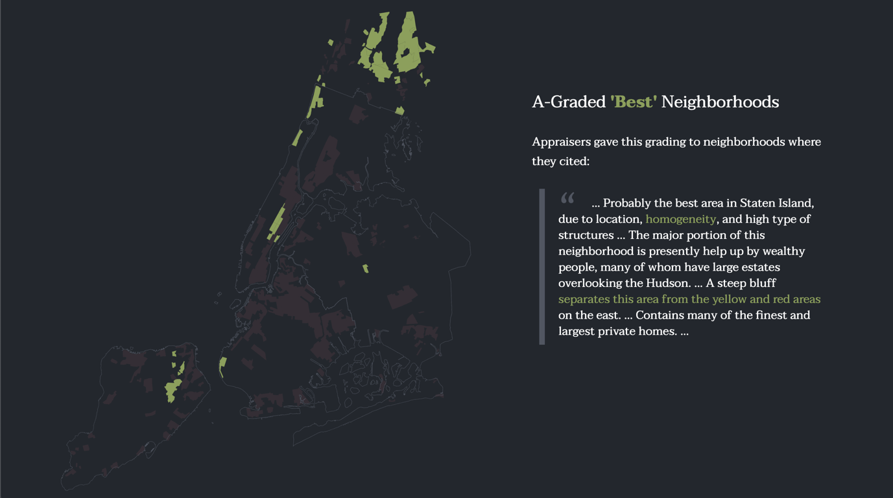

Figure D2: ‘Redlining Explainer’ section for A-Graded “Best” zones

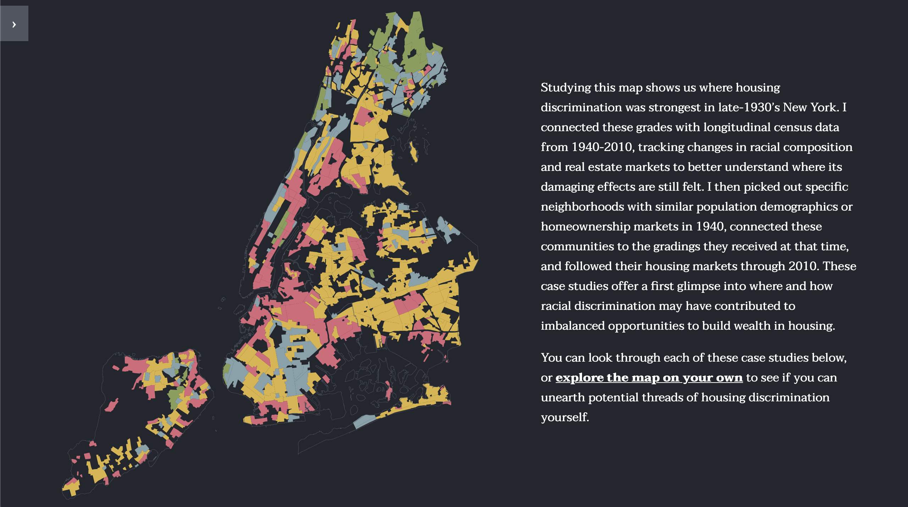

Figure D3: Full redlining map of New York City including a call to action allowing users to jump right to explore view

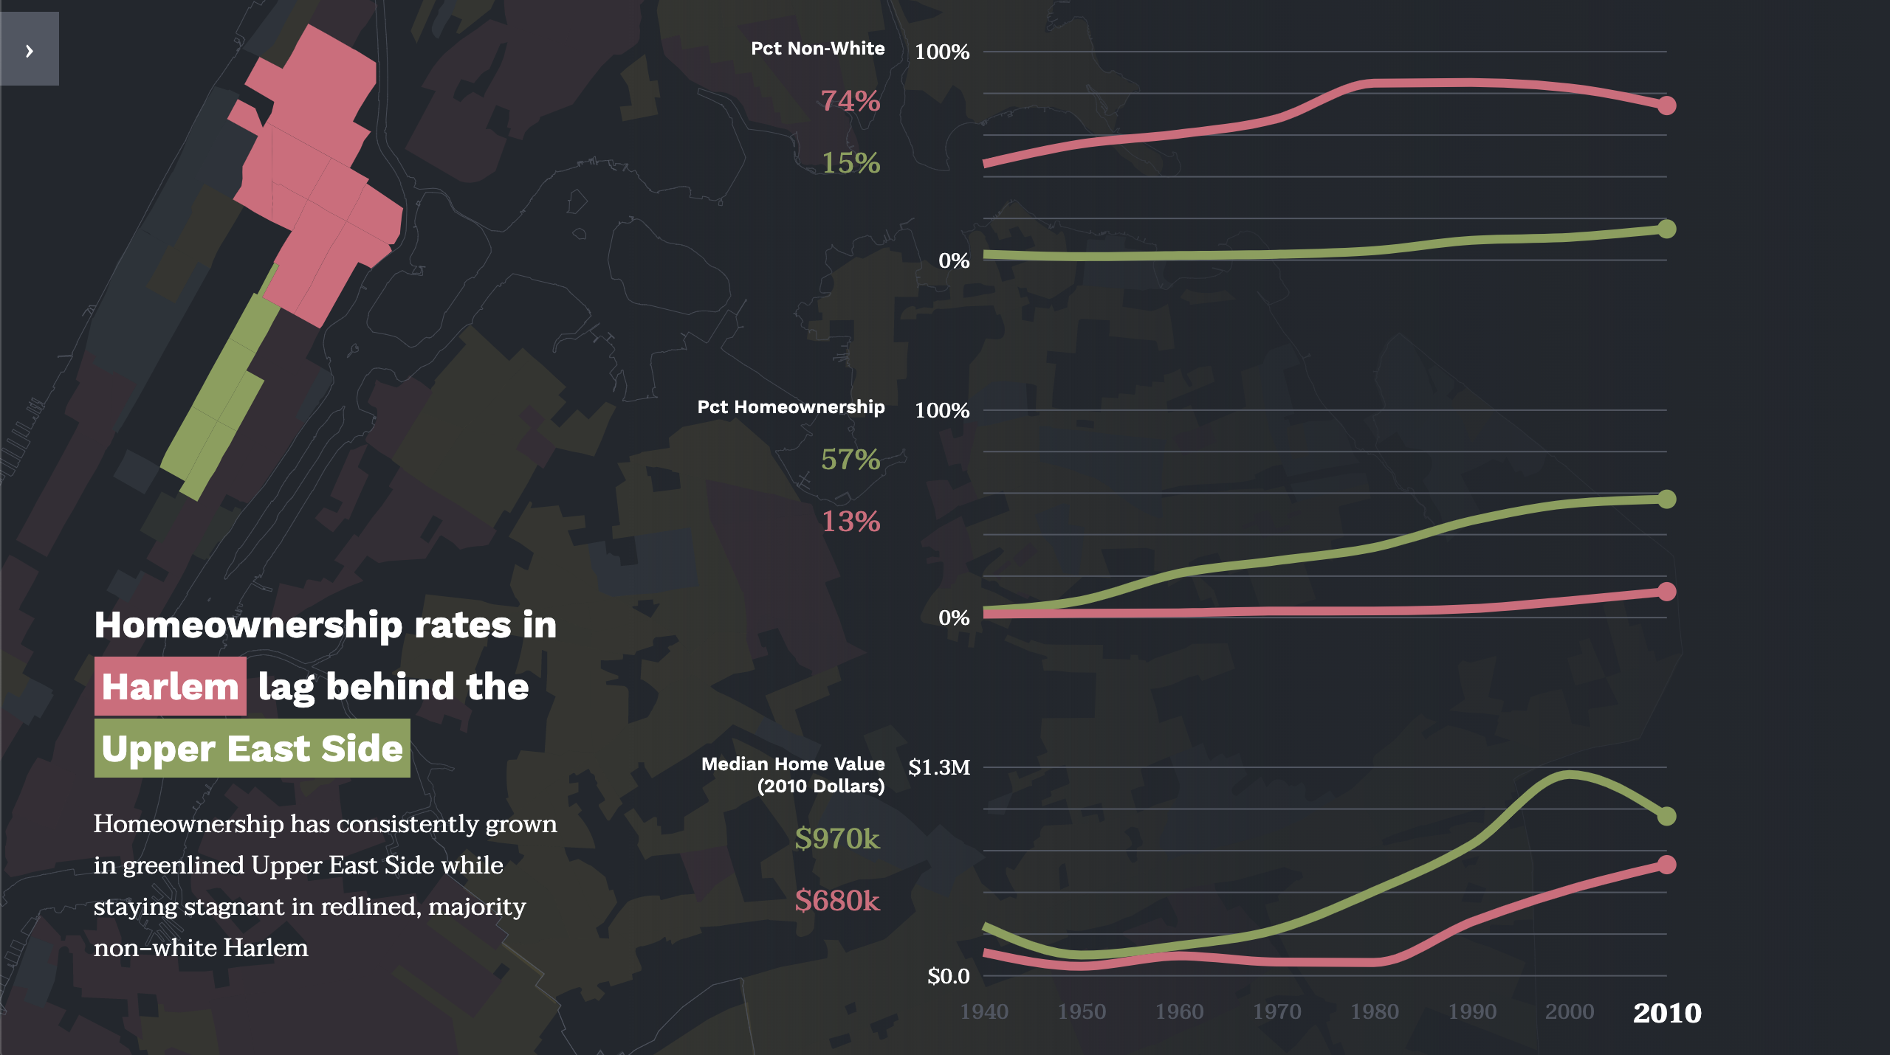

Figure D4: Example comparison view with map boundaries, sparklines, hover-over tooltips, and takeaway text

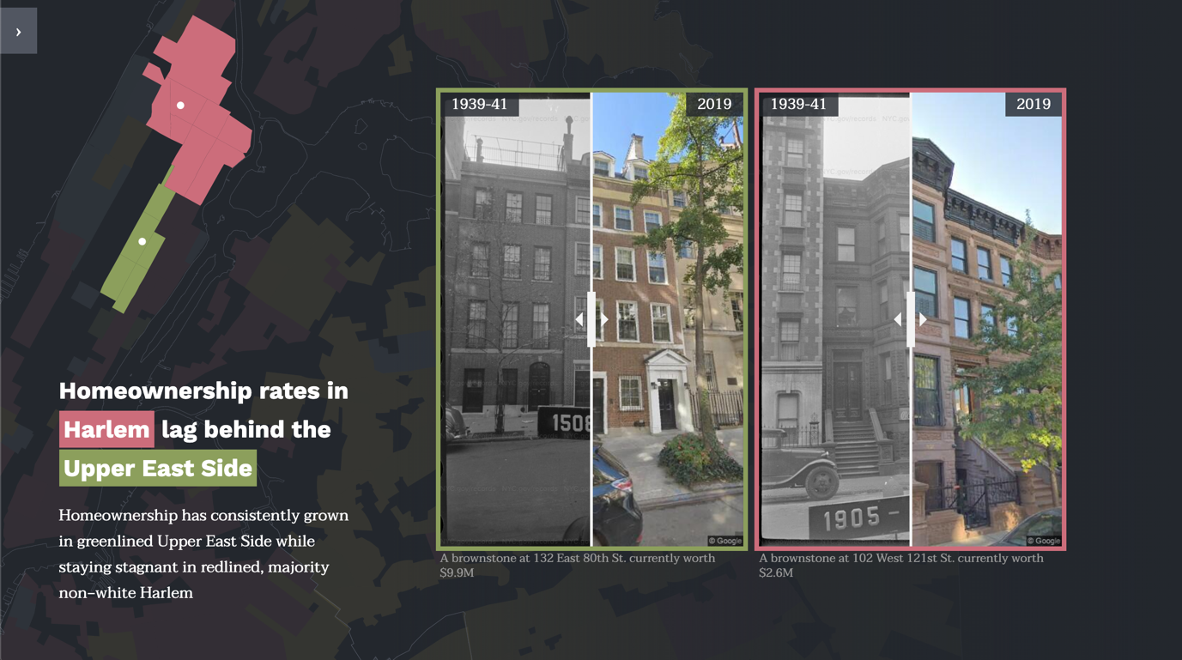

Figure D5: Example comparison view with building images and takeaway text

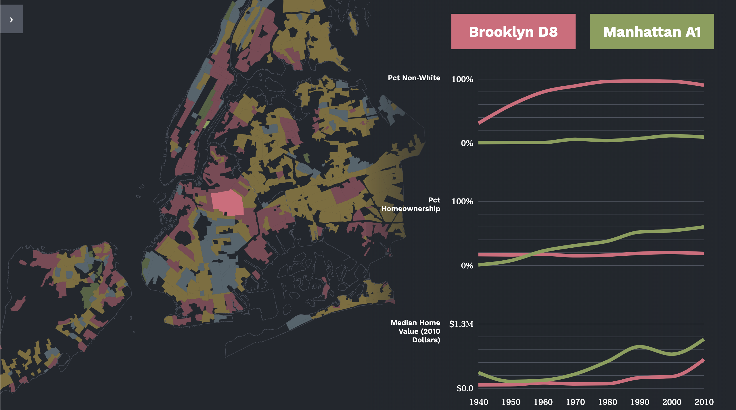

Figure D6: Explore view with interactive map (allowing panning, zooming, hovering, and clicking) with sparklines and neighborhood names

1. I used shapefiles with a basis of *2000 TIGER/Line+* for each census year, whose boundaries are primarily derived from the U.S. Census Bureau’s 2000 TIGER/Line files
2. I convert median home values to 2010 dollars using inflation estimates from *in2013dollars.com*, a reference website maintained by the Official Data Foundation; raw data from its calculations come from the Bureau of Labor Statistics’ Consumer Price Index (CPI). Specific inflation estimates are available in Appendix B.